

INSIGHT
My looking forwards booklet

Early intervention in psychosis service
Co-produced by staff, service users and carers

Welcome to your ‘my looking forwards’ booklet

Included in the booklet you will find your moving forwards plan, wellness plan and lots of information on different organisations and services which provide a wide range of support
and advice.

We understand that moving on from a team such as Insight can feel daunting. This booklet
has been co-produced by those who have been involved with Insight, including people who
have used the service, carers and team members, to help reduce any fears you may have
about how to manage your wellbeing and access support if you feel it will help in the future.
You may like to read through and personalise your booklet with support from team members
whilst you are working with Insight. Your booklet can also be used alongside support from
different mental health teams or your GP.

 This booklet is divided into parts.

Parts: 1 – 3
These parts contain information personal to you, a place to focus on your own accomplishments, along with your moving forwards and wellness plans.

Parts: 4 – 7
These parts contain details of local mental/physical wellbeing support services.
Also included are details about local organisations based in the community who
can support people around social inclusion.


Included in these parts are two spotlights containing more information on the
Wakefield Recovery and Wellbeing College and the Wakefield Hearing Voices group.

Contents
Part: 1
- My accomplishments, strengths and things I am proud of
- Five ways to wellbeing and my wellbeing plan
- My moving forwards plan

Part: 2
- If you need help now – contacts for my health care
- Crisis helpline contacts
- Here For You (ages 16+)

Part: 3
- My wellness plan

Part: 4
- Local mental health and wellbeing support organisations.
- Social community groups
- Live Well Wakefield
- Fibromyalgia support
- Man Matters
- South West Yorkshire Partnership NHS Foundation Trust carers’ passport
- Spotlight on Wakefield Recovery and Wellbeing College
- Spotlight on Wakefield Hearing Voices group

Part: 5
- Help at the Hub and Citizens Advice drop-in sessions

Part: 6
Other useful support information which includes:
- Bereavement * Pastoral and spiritual care
- Housing * Support for people who self-harm
- Finance/debt * Online support
- Employment * Wakefield – Stanley Family Hub
- Domestic abuse * Canine befrienders

Part: 7
- Volunteering with South West Yorkshire Partnership NHS Foundation Trust
- Thank you from the team

Part 1
My Accomplishments, Strengths & Things I am Proud of
Below is a space where you can note down how you feel you have progressed – maybe during your time with the Insight team, or since you began to experience distress related to your wellbeing. This could be in the ways you feel stronger, or anything you are proud of.

There is no such thing as a small achievement, they are all important and writing
them down can help you see how far you have come.



Why not contact the
Wakefield Recovery and Wellbeing College and ask about their free, friendly educational ‘Mindfulness’ courses, open to anyone over the age of 16.

www.wakefieldrecoverycollege.nhs.uk

Tel: 01924 316946



Part 1

Five ways to wellbeing

There are five steps you can take to improve your mental health and wellbeing. Trying these things could help you feel more positive and able to get the most out of life.

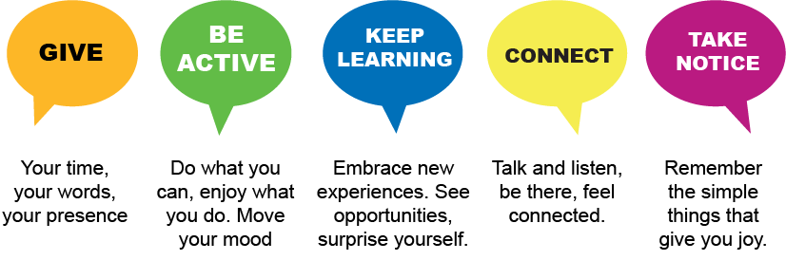


- Give to others

Acts of kindness can help improve your mental wellbeing by:

- Creating positive feelings and a sense of reward
- Giving you a feeling of purpose and self-worth
- Helping you connect with other people

It could be small acts of kindness towards other people, or larger ones like volunteering in your local community.


- Be physically active

Being active is not only great for your physical health and fitness, but also it can improve your mental wellbeing by:

- Raising your self-esteem
- Helping to set goals or challenges and achieve them
- Causing chemical changes in your brain which can help to positively change your mood


- Learn new skills

Learning new skills can also improve your mental wellbeing by:

- Boosting self-confidence and raising self-esteem
- Helping you to build a sense of purpose
- Helping you to connect with others


- Connect with other people

Good relationships are important for your mental wellbeing as they can:

- Help you to build a sense of belonging and self-worth
- Give you an opportunity to share positive experiences
- Provide emotional support and allow you to support others

- Pay attention to the present moment – take notice (Mindfulness)

Paying more attention to the present moment can improve your mental wellbeing. This
includes your thoughts and feelings, your body, and the world around you. Some people
call this awareness ‘mindfulness’ which could include going for a walk and noticing the environment or eating your favourite snack, paying attention to the flavours and texture. Mindfulness can help you enjoy life more and understand yourself better. It can positively
change the way you feel about life and how you approach challenges.



Part 1

Wellbeing plans – This is a space to plan and note down enjoyable activities you can do which promote your wellbeing. You may like to think about the five ways to wellbeing, explained on the previous pages. We have included a fortnightly template for the first month, along with templates for a further two months as shown below. Please feel free to photocopy them if you require more.

Month …………………………………….. Weeks 1 and 2

Monday | Tuesday | Wednesday | Thursday | Friday | Saturday | Sunday

Month …………………………………….. Weeks 3 and 4

Monday | Tuesday | Wednesday | Thursday | Friday | Saturday | Sunday

Part 1
Month ………………………………….

Monday | Tuesday | Wednesday | Thursday | Friday | Saturday | Sunday

Month ………………………………….

Monday | Tuesday | Wednesday | Thursday | Friday | Saturday | Sunday

Moving forwards: from the Insight team plan

This blank section is for you to jot down any notes you may have.
You may wish to talk about these with your care-co-ordinator.



*

*

*

*

*

*

*

*

*

*

My notes:

Part 2

Contacts for my health care

Contacts for my health care

Office hours contact:
Out of office hours contact:

NHS 111

Press option 2
for mental health
GP contact number:

Opening hours:

OR
What is a mental health care plan?

- A record of needs, actions, and responsibilities
- A tool for managing risk
- A plan which can be used and understood by service users/patients, families and carers and other agencies, as well as colleagues, in a crisis
- Something which people feel they own
- Based on a thorough assessment of need
- Co-ordinated by the most appropriate person, such as a care co-ordinator
- Produced in the most appropriate form
- Shared effectively with those who are part of it
- The written record of a plan of action developed with the person to meet their health and social needs
In an emergency, please go to your nearest urgent care centre, A&E, or call 999.
Other known health professional

Name:

Phone number:
Part 2

If you are feeling down, and not sure where to turn, call or text one of the relevant services below for FREE support and advice.

Shout | Text 24/7  85258 | Free 24/7 text messaging service for anyone in the UK needing support with their mental health.
Samaritans | Call  116 123 | Free 24/7 service – whatever you’re going through, contact them for free from any phone.  https://www.samaritans.org/
Cruse Bereavement Support | Call  0808 808 1677 | Free support from all UK landlines and mobiles.  Open Monday – Friday 9.30am – 5pm and Tuesday 1pm – 8pm.  Closed weekends.
National Gambling Helpline | Call  0808 80 20 133 | Free 24/7 helpline where you can talk to someone for help, advice, and support about gambling
Turning Point Inspiring Recovery | Call  0300 123 1912 | Free support around drug and alcohol related issues.  https://www.turning-point.co.uk/services/wakefield-inspiring-recovery#opening-times
NHS 111 | Call  111 | Urgent mental health support in South and West Yorkshire. Select mental health option.

 Part 2 

Here for You Service- (Age 16+)

Section 6
Opening Times: Every day from 6pm.
Feeling down and not sure where to turn? Here For You’s local out-of-hours services offer face-to-face support for those nights when you are struggling or may have thoughts of self-harm or suicide. The Wakefield service is open to anybody aged 16 years and older living in Wakefield and the Five Towns who feel they need same night support, but do not require medical or specialist attention.

Same Day Urgent Mental Health Support in a Safe Place.
Now Open Earlier and Offering More 1-to-1 Support When You Need It the Most.
Here For You are open every day of the year for anybody aged 16years or older, who is struggling to cope or experiencing thoughts around suicide or self-harm.
They offer face-to-face confidential support in our local safe spaces across Leeds, Kirklees, and Wakefield, which are free to access without the need for GP or hospital referral.
You do not need a home address or local GP to access this service.
You can access us if you are new to the area, or you are homeless.
They support people based on their nearest hospital as A&E is not always the best place when you are struggling with your emotions.

Support Available:

1-to-1 urgent support in person.
These are 45minutes per session with one of their trained, local staff, to help you talk through how you are feeling on that day and explore how they can support you to stay safe for the rest of the evening.
They can also help you to find support in your community or from other services to help you stay safe and well for longer. This might be for mental health support, or it might be to find help with housing, finances, food bank, domestic abuse, drugs and alcohol, or anything else you are struggling with.
After 1-to-1 support, you will be able to decompress and unwind in the Social Space, to help you feel safe to go home. Their Social Space offers a range of distraction activities and a comfortable place to help yourself to free, hot drinks and light snacks.

A Welcoming Social Space.
We recognise that for many people feeling alone can affect our mental health and make it harder to cope.
To support people to have a safe space to be around others, they have a welcoming Social Space from 8pm-Midnight for up to 6 people at a time.
They offer free refreshments, a range of activities and a safe space to simply sit and be around others to remind you that you are not alone.

1-to-1 urgent support on the phone.

They understand that you may not always feel safe or able to leave your home for a support, so in urgent situations where you feel you would like our support but are unable to get to us, Here for You can offer our 45minute supports over the phone.

Urgent Care Boxes:

They try to give urgent care packs if you are currently struggling in your home or are homeless. These generally include:
- Bottled Water
- High energy snacks
- Soap and sanitiser
- Sanitary products
- Personal Safety Alarm

Please be aware these are limited and may not always be available as they provide these through donations.

Get in touch

07776 962815
https://touchstonesupport.org.uk/hereforyou/here-for-you-wakefield/

The Workspace, Space Station, 6 Denby Dale Road, Wakefield, WF1 1HR

Part 3:

My Wellness Plan

You may find it helpful to complete your ‘my wellness plan’ with someone you trust.

Part 1

This is a plan to help you identify how you feel and act when you are well and how you can manage your wellbeing.

- When I am well (describe yourself when you are feeling well).

- Things I can do for myself each day, and less often to look after my wellbeing.

DAILY:

Less often:

Description | How often

This is the second part of your wellness plan and has been included in this discharge pack to help you identify signs that you may becoming unwell and how to help manage these signs. You may wish to contact some of the services provided in this booklet for support.



Things I experience when I start to become unwell (you may have heard these described as early warning signs) and what I can to do to help.

Signs/symptoms | How I can help manage this

My distress plan

The following section focuses on any potential crisis and how to manage this. Please do not be alarmed by this. It has been included to help you manage a potential crisis and does not mean that we are expecting you to experience one.

Signs that things are becoming worse, I may be reaching a crisis and how I can help manage them.

Signs/symptoms | How I can help manage this

Signs that I am in crisis and my plan to manage them.

List signs that you notice about yourself, or things others may notice which indicate you are in crisis.
Signs/symptoms | How I can help manage this/how others can help

Signs that others can look for which indicate that I am in crisis and may need others to take over my care.

Signs/ symptoms

My supporters/carer

These are people you would like to be contacted if you are in crisis. You may also like to list things they can do or avoid doing to support you.

Name | Connection | Telephone number | I would like this person to, or avoid doing
You may also like to think about what medication you would prefer to take or avoid, treatments which have been helpful in the past during a crisis, and how you would prefer to be supported, such as at home or in hospital.
Medication *
*
*

Avoid medication *
*




Helpful treatments *
*
*
*



Support such as home/hospital

Home Hospital



Signs when I am out of crisis – I will know I am ‘out of crisis when I:

Signs/symptoms

Recovery supporters/carers list

I would like the following people to support me if possible, during this post crisis time:

Name | If possible, I would like them to:

Part 4

We all need support at some time in our lives, whether it is for our mental or physical
wellbeing. The following local organisations and services offer support and/or workshops for you to learn more about a variety of health and wellbeing subjects, enjoy social interaction, meet new people and get out of the house into the fresh air.
Andys Man Club (For men aged 18 +)

Andy’s Man Club run face to face clubs every Monday (except bank holidays) from 7pm – 9pm for all men aged 18 and over. They offer peer to peer support in a safe, non-judgemental environment and it can be a great place to meet new people and get things off your chest. Men are more than welcome to attend a club and can just turn up. There is no pressure to talk; men can come along, grab a brew, listen, and see how it works. The facilitators will be at the door from approx. 6.45pm to meet men and show them where to go.

Men are welcome to attend any club. Andy’s Man Club’s website and social media channels are updated live as changes occur, so check the website before attending each week.

Find the address of all clubs at www.andysmanclub.co.uk or by emailing info@andysmanclub.co.uk



For children and young persons
Night OWLS (for children and young people)

West Yorkshire Night OWLS is a confidential support line for children, young people, their parents and carers who live in Bradford, Leeds, Calderdale, Kirklees and Wakefield.

If a child or young person you care for is in a crisis and you are concerned about their emotional wellbeing contact Night OWLS.

Call: Freephone 0800 1488 244

Text: 07984 376950

Chat online: www.wynightowls.org.uk

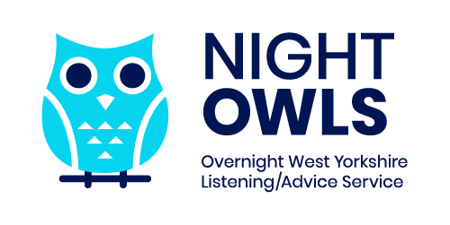

Community Centres:

There are lots of local community centres based in the Wakefield district who offer plenty of social groups for all ages.

Portobello Community Centre is in central Wakefield and offers a craft and camera group, for example.


Portobello craft and camera group

Every Tuesday, 12:30pm – 2pm (no need to book)
Portobello Community Centre, WF2 7JJ
Cost: £2, includes refreshments. First session free.

Attendees participate and share ideas and skills in craft / art and photography, including:

Knitting, crochet, needle felting, photography, computer use, spinning (textiles), ceramics, painting, drawing, lino cutting, book binding, candle making, soap making, piñata making, staining glass, glass painting, machine collage embroidery, ribbon embroidery, silk painting, cyanotype and block printing.

The group provides open and equal opportunities for all aged 18 and over.

The group was started and continues to be run by people from the local Wakefield area.

As well as weekly meetings, the group has also taken part in other special projects, including producing public art in the area, taking part in Portobello community events and contributing to and exhibiting their work in the district.

The group also communally cook and sit down to celebratory meals 2 – 4 times a year.

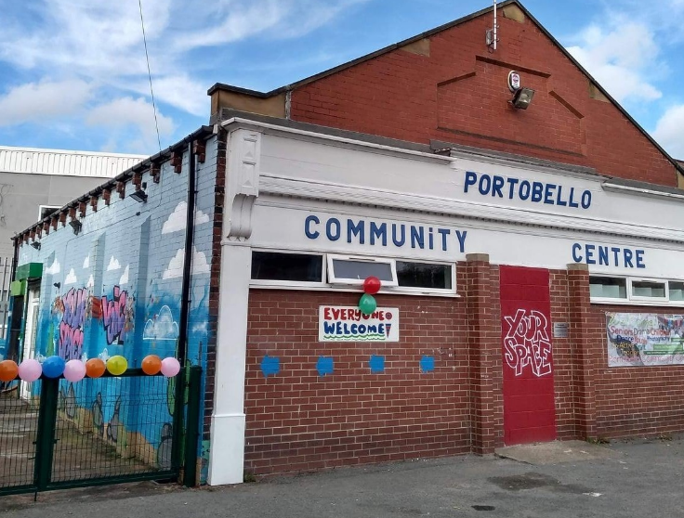

Local community venues

Here is a brief list of local community venues that offer different social wellbeing activities.

St George’s Community Centre, Lupset, Wakefield – 01924 369631

The Cluntergate Centre, Horbury, Wakefield - 07873544948

St Catherine’s Church, Wakefield – 01924 211130

Balne Lane Community Centre, Wakefield – 01924 373558

Havercroft and Ryhill Community Centre, Wakefield – 01226 727824

Agbrigg and Belle Vue Community Centre, Wakefield – 01924 303337

St Swithun’s Community Centre, Eastmoor, Wakefield – 01924 361212

St Mary’s Community Centre, Chequerfield, Pontefract – 01977 705341

Ferrybridge Community Centre, Knottingley – 01977 676056

Glasshoughton Community Centre, Castleford – 01977 511234

Local support


Live Well Wakefield provides social prescribing and self-management support to adults aged 18+ who live in the Wakefield district or are registered with a Wakefield district GP.
The social prescribing service supports people who are experiencing non-medical needs impacting on their wellbeing, such as financial issues, social isolation, or housing needs. Live Well Wakefield helps people to identify and prioritise their needs and provides access to information and advice on local services and activities.

The self-management service offers workshops which support people with long term conditions to develop tools and techniques to help them take greater control of their own health and wellbeing.

The Live Well Wakefield service can be accessed through a self-referral, or a referral from a carer, relative, or professional with consent from the individual being referred.

To make a referral, complete a referral form on the website: www.livewellwakefield.nhs.uk or call 01924 255363 (Monday – Friday, 9am – 5pm).

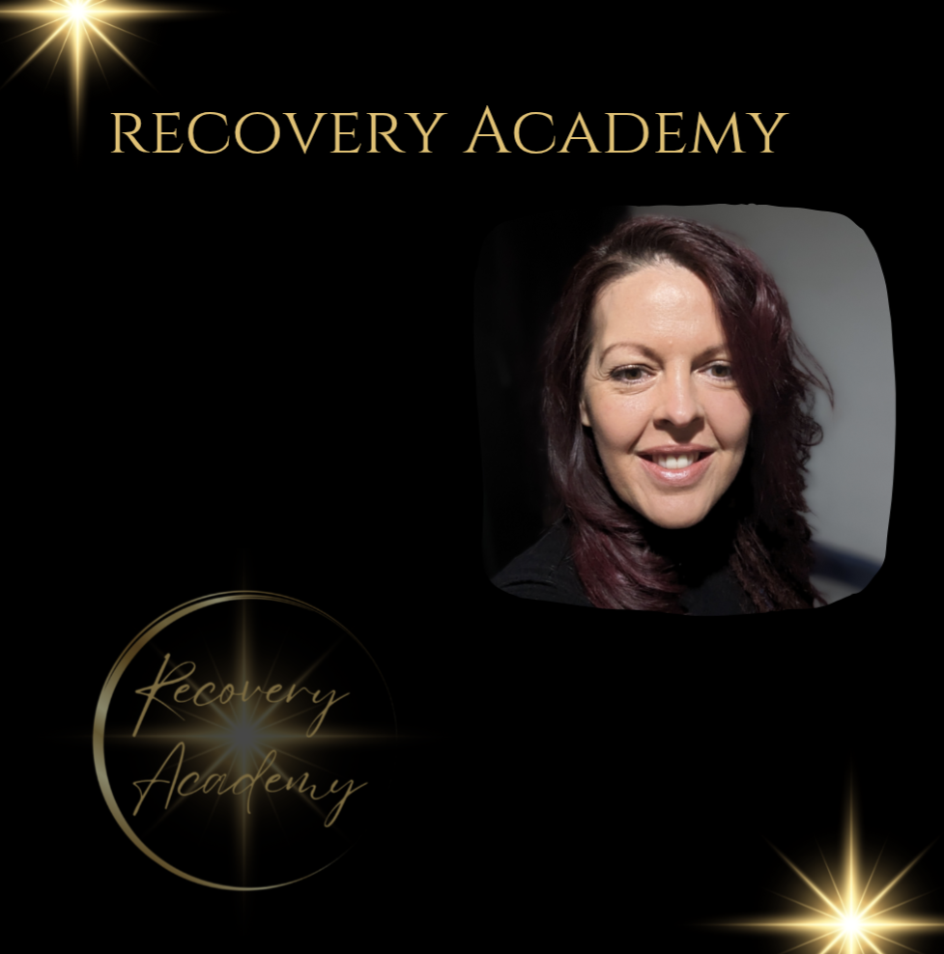
Recovery Academy and fibromyalgia support

“Hi, I am Keilly, founder of the Recovery Academy. I am a social worker of 12 years in adult mental health services. I am also a transformational trauma informed coach that specialises in fibromyalgia and nutrition, as this plays a significant part in symptom reduction and promoting wellbeing both physically and mentally. I am also completing a course in naturopathy.

“So why the Recovery Academy? I am a fibromyalgia warrior too, and I've been on my journey to recovery since my diagnosis in 2016. I struggled with symptoms for many years before this, but with limited support available through the medical route, I decided to take control of my own health and look at holistic ways to heal my symptoms and to understand the nature of fibromyalgia. Over the years, I have reduced my symptoms significantly and have a better quality of life.

“Recovery is different for everyone, and I acknowledge, appreciate, and honour that. We all walk our own path; I am just here to guide people to heal themselves from the inside out. I always practice from a non-judgemental, person-centred, and strengths-based approach and work in partnership with my clients whilst promoting accountability and responsibility.

“I created a course 5 years ago called 'Freedom from Fibromyalgia' that I deliver through the Wakefield Recovery and Wellbeing College. This is a free introductory course where I teach hope in recovery, provide an overview and understanding of fibromyalgia and discuss lifestyle adjustments and support networks for a better quality of life.

“I have also worked closely with carers over my years in social care and prior to this I was also a carer. I understand the work you put in and the emotions and energy involved and the limited support available to you. You are welcome to join the Freedom from Fibromyalgia group by contacting the Wakefield Recovery and Wellbeing College on 01924 316946.

Best wishes, Keilly.”

Join the Recovery Academy support group on Facebook: https://www.facebook.com/share/g/19sUcmMphw/

Contact Keilly via Facebook:
https://www.facebook.com/share/1F9g8kUgv2/

Contact Keilly by email:
info@betruetoyou.co.uk

This is a part private and not for profit organisation.

MAN MATTTERS – 01924 787507 / 01924 787501

Man Matters is a project at GASPED offering a range of practical and emotional support to anyone who identifies as male, is over 18 and lives in the Wakefield district. They work with anyone who identifies as male to improve self-worth and overcome challenges such as suicidal tendencies and low self-esteem.

Services include:

- 1-to-1 practical and emotional support
- Person centred counselling
- Coffee groups

Male victims of domestic abuse – 01924 787507 / 01924 787501
Offering a safe space for men aged 18+ living in the Wakefield district who have been affected by domestic abuse to talk openly.

Male victims of sexual abuse –01924 787507 / 01924 787501
Offering a safe space for men in West Yorkshire aged 18+ who have been affected by sexual abuse to talk openly.

How to refer:

You can self-refer or refer on someone’s behalf with consent.

Call
Main GASPED line – 01924 787501
Man Matters referral line – 01924 787507

Online
A referral form is available online – www.gasped.co.uk / www.manmatters.org

You can also email for a referral form and then email it back – resourcecentre@gasped.co.uk / manmatters@gasped.co.uk

Once a referral has been made, after about 16-20 weeks at current, the client will be allocated a worker who will conduct a 50-minute telephone initial assessment. This will then determine what type of support they can be offered and whether it will be via face to face, telephone or online.

Address
Opening hours:
Monday 9am – 8pm
Tuesday – Friday 9am – 5pm

GASPED office, 5a Cheapside, Wakefield WF1 2SD
Please note they do not accept drop ins.

Man Matters coffee groups

- Monday evening, Eastmoor Rugby Club
- Wednesday afternoon, Ferrybridge Community Centre
- Friday morning, Airedale Library

Please call for times and to express interest.

Carers passport
Do you attend the Insight service and have someone who cares for you such as a relative or friend? If so, tell them about the carers’ passport and ask them to speak with your care co-ordinator who can complete the passport with them.

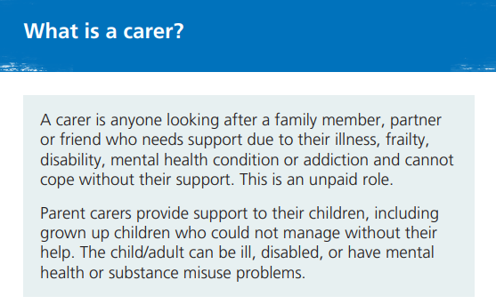

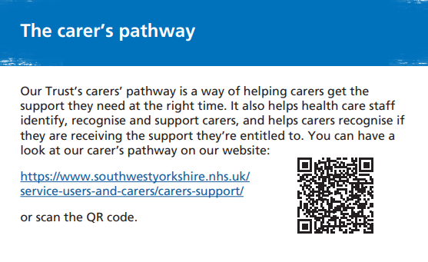
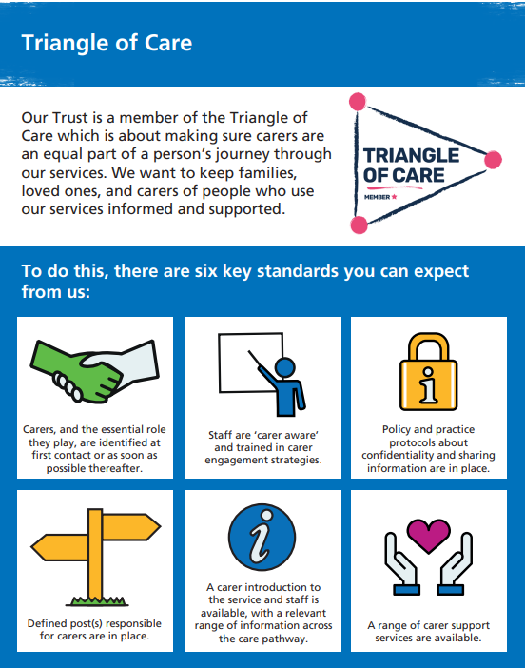
Wakefield Recovery and Wellbeing College

Wakefield Recovery and Wellbeing College publish a monthly newsletter called ‘The Supporter’ which gives you news and information about the college and the courses on offer, along with local support/events information, quizzes, and poems. If you would like a copy, give them a call.

01924 316946
www.wakefieldrecoverycollege.nhs.uk

Established in 2014, the Wakefield Recovery and Wellbeing College provides short, free-of-charge (for everyone), wellbeing-focused courses and workshops to any member of the public aged 16+.

Their small groups, offered both face to face in various venues across the Wakefield district and online via Microsoft Teams, are co-produced by people with professional and lived experience, providing a supportive environment to empower you to learn more about and take control of your own health and wellbeing (or that of someone you support).

The informal college offers the opportunity to learn from each other, with no tests, exams, assessments, or classroom layouts. Courses and workshops cover topics around understanding and managing mental and physical health and wellbeing, physical activity (with a fun approach) and hobbies/new skills.

Many sessions are co-produced and co-facilitated by volunteers and there are lots of new volunteering opportunities for those who wish to get more involved or achieve a personal goal.

You can attend any course or workshop regardless of where you live, and you can self-enrol. You can also bring someone with you for support – please make sure they enrol to secure a place. Visit the website or call the college to enrol.

01924 316946
www.wakefieldrecoverycollege.nhs.uk

Wakefield Recovery and Wellbeing College values
- Co-production is at our heart
- We offer education and not therapy
- Change is a good thing
- Partnerships are key
- The right support is vital
- We follow the CHIME principles of Connectedness, Hope and optimism, Identity, Meaning, and Empowerment.
Address:
The Workspace,
Space Station,
6 Denby Dale Road,
Wakefield,
WF1 1HR

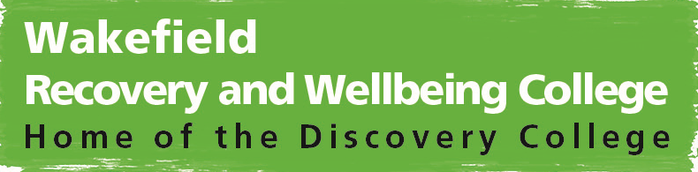

Wakefield Hearing Voices Group

A friendly peer support group for people who hear voices, see visions, or have other unusual perceptions. The group is open to anyone who hears voices or has other unusual perceptions, whether they use mental health services or not. People can bring a friend, family member or worker if they’d like to.

Mondays, 12pm – 1:30pm (excluding Bank Holidays)

Agbrigg & Belle Vue Community Centre
Montague Street
Wakefield
WF1 5BB

Please contact 01924 316936 if you would like to talk to someone about this group.




Part 5
Help at the Hub & Citizens Advice Drop-In Sessions

There are various hubs in Wakefield which offer free support on topics such as money,
wellbeing and jobs to residents. They also offer drop-in sessions with Wakefield Citizens
Advice. You don’t need to book an appointment, just turn up if you would like information
on budgeting, health, or government funding, for example.

Hub | Address and phone Number | Opening hours | Citizens Advice  drop-in hours
Queen’s Mill | Aire Street  Castleford  WF10 1JL  01977 556 741 | Monday to Friday:  10am to 3pm | Wednesdays:  10am to 12pm
St Mary’s Pontefract | Chequerfield Pontefract  WF8 2AY  01977 705 341 | Monday to Friday: 9am to 4pm | Wednesdays:  10am to 12pm
Havercroft and Ryhill Community Learning Centre | Mulberry Place  Wakefield  WF4 2BD  01226 727 824 | Monday to Friday: 9am to 4pm | Wednesdays:  10am to 12pm
Kellingley Club | 25 Marine Villa Rd  Knottingley  WF11 8ER  01977 673 115 | Monday to Friday: 8am to 1pm | Wednesdays:  10am to 12pm
St George’s | Lupset Broadway Lupset  Wakefield  WF2 8AA  01924 369 631 | Monday to Friday: 9am to 5pm | Tuesdays:  10am to 12pm
Eastmoor Community Project | Arncliffe Road Wakefield  WF1 4RR  01924 361 212 | Monday to Friday: 9am to 5pm | Tuesdays:  10am to 12pm
Westfield Centre | 26 Westfield Lane  South Elmsall Pontefract  WF9 2PU  01977 642 335 | Monday to Friday: 8:30am to 4pm | Tuesdays:  10am to 12pm
Lightwaves Leisure and Community Centre | Lower York Street Wakefield  WF1 3LJ  01924 360 158 | Monday to Friday:  9am to 5pm | Tuesday:  10am to 12pm
Red Roof Centre CIC | Wakefield Road Kinsley  WF9 5BP  01977 610931 | Monday to Friday: 9am to 12pm | Tuesdays:  10am to 12pm

Wakefield Citizens Advice also offer the below drop-in sessions

Venue | Address | Drop-in times
Citizens Advice Wakefield District | 27 King Street Wakefield  WF1 2SR | Mondays, Tuesdays and Wednesdays:  10am to 3pm
Community Shop | Hill Top  Pontefract Road Knottingley  WF11 8EE | Every 2nd and 4th Monday of each month:  10am to 2pm
Pinderfields Hospital - Floor E | Aberford Road  Wakefield  WF1 4DG | Monday to Thursday:  10am to 12pm
Warwick Ahead Hub | 5 Pinewood Place Knottingley  WF11 0QH | Fridays:  10am to 12pm
St Giles Parish Church | Market Street Pontefract  WF8 1AT | Wednesdays:  10am to 12pm
Ossett Library | Town Hall  Market Place  Ossett  WF5 8BE | Mondays:  10am to 12pm
Hemsworth Town Council Community Centre | Bullenshaw Road Hemsworth  WF9 4NE | Every 2nd and 4th Thursday of each month:  10am to 2pm
Upton and North Elmsall Village Hall | Harewood Lane Upton  WF9 1JB | Every 1st and 3rd Wednesday of each month:  10am to 2pm
Featherstone Library and Community Centre | Victoria Street  Off Station Lane Featherstone  WF7 5BB | Tuesdays:  10am to 12pm

Part 6

There are lots more support organisations based in the local community that can
support adults and young people with:

- Bereavement
- Housing
- Finances
- Employment
- Domestic abuse
- Pastoral and spiritual care
- Self-harm
- Alcohol support
- Online support

Bereavement

Wakefield & District Bereavement Support Service – Wakefield Families Together

Provides assistance in coping with grief. You can refer yourself or ask a GP or health professional to make a referral.

www.wakefieldfamiliestogether.co.uk

Housing support


Healthy Housing Pathway

The Healthy Housing Pathway allows Wakefield residents to apply or be referred to a range of services focused on housing conditions, financial difficulties and difficulties heating the home. This is the best way to access services - especially if you're not sure about which specific help is required as the pathway can refer you to all relevant departments by just completing one short application form.

www.wakefield.gov.uk/healthy-housing

MoneySmart

The MoneySmart team helps people with financial difficulties such as debt, mortgages, and budgeting with support from qualified financial advisors. Some of the things they can help with include access to grants, budgeting support and help to reduce outgoings and maximise income.

01924 305892

Home energy team

The home energy team provides free assistance to residents to help replace broken boilers and increase energy efficiency by providing insulation. They also have ongoing periodic schemes that can help residents gain access to renewable energy sources, interest free loans for repairs or energy efficiency measures and help residents get connected to the gas network.

01924 305887

Housing enforcement team

The Housing Enforcement Team deal with housing standards issues in privately rented and social housing accommodation. They provide support if landlords are not making required repairs to the property and issues like damp/mould are being caused as a result. They can come and conduct property inspections and give notices to landlords of required works they must undertake to bring the property back up to standard.

01924 306665

All these services can be accessed by applying to the Healthy Housing Pathway at:

www.wakefield.gov.uk/healthy-housing

Email: healthyhousing@wakefield.gov.uk

Financial support

Free support and guidance to help you take control of your finances.

www.getcashwise.co.uk
Telephone: 01977 724651 
Text: 07860 019867

Employment support

Step Up is Wakefield Council's dedicated skills and employment service, offering free, personalised 1 to 1 support for both unemployed and employed individuals from age 16+. Whether you require help with CV and cover letter writing, interview preparation, exploring training and qualification opportunities, seeking self-employment support, job searching, or interview techniques, experienced advisors are available to guide you every step of the way.

They can also provide support in building confidence, improving health and wellbeing, volunteering, claiming benefits, managing money and debt. They also have dedicated advisors for addressing matters such as substance misuse, mental health, and disabilities.

To get in touch or make a referral, email stepup@wakefield.gov.uk or call 01924 303334
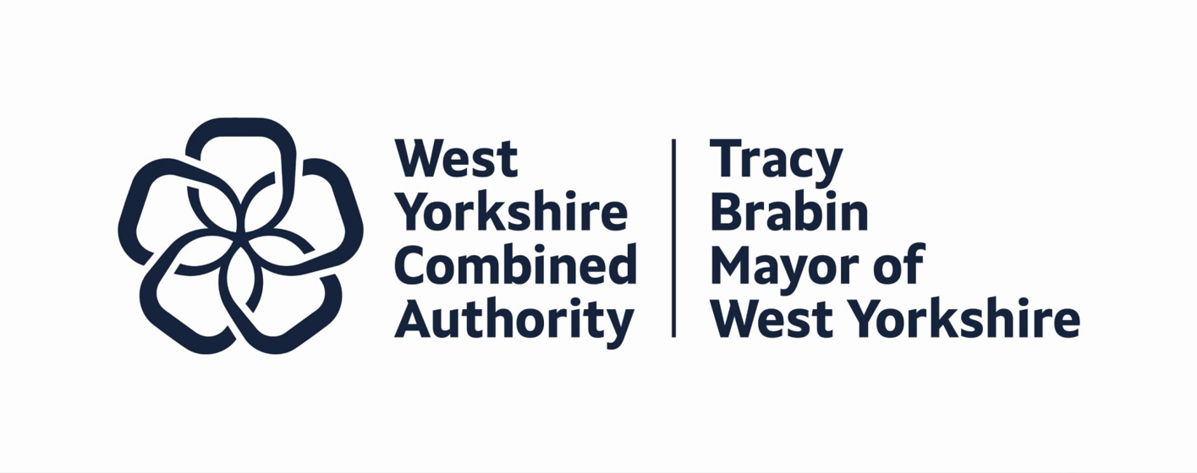

Domestic Abuse



Wakefield District Domestic Abuse Service (WDDAS)

Support for victims experiencing domestic abuse. You must be a Wakefield resident with a Wakefield GP to access the service. If you are unsure, please contact the team before making a referral.

If you are in immediate danger, please call the police on 999.

If you would like support and advice around domestic abuse, call the helpline on:
0800 915 1561

Working hours are Monday to Thursday 8:30am – 5pm and Friday 8:30am – 4:30pm.

If there is no answer, please leave a message with contact details and a time that’s safe to call
you back, or email domesticabuse@wakefield.gov.uk and the team will contact you. If
you email out of hours, your query will be responded to in working hours.

https://www.wakefield.gov.uk/our-people-and-communities/safer-wakefield/domestic-abuse/wakefield-district-domestic-abuse-service

Pastoral & Spiritual Care Fieldhead Hospital

Our pastoral and spiritual care service is based in our wellbeing and learning centre at Fieldhead Hospital, Wakefield.
Pastoral care offers a person-centred approach to always supporting people - especially when dealing with difficult and challenging circumstances. It encourages people to work with their own value and belief systems to find hope, healing and spiritual wellbeing.
Spiritual care recognises the links between body, mind and spirit. It may involve:
- Re-engaging with the energy and positivity of life through practices such as meditation, mindfulness, prayer and bodywork.
- Growth in consciousness and awareness
- A deepening of compassion (including self compa​ssion) and insight
- A greater commitment to personal development
- A growing commitment to the wellbeing of others in service and community involvement

For more information, contact us or call in.

Pastoral and spiritual care
Fieldhead
Ouchthorpe Lane
Wakefield
WF1 3SP

Telephone: 01924 327318
Email: pastoral.care@swyt.nhs.uk

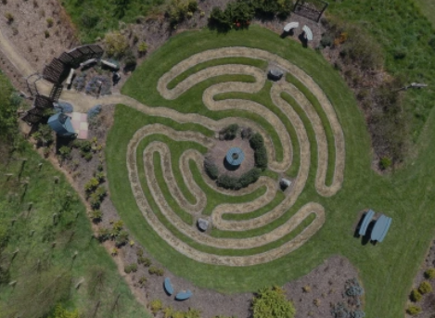
Self harm

Battle Scars


Battle Scars offers peer support to anybody struggling with self-harm in whichever form. They offer a wide range of services and resources:

- Virtual peer support groups (daytime and evening) with no requirement to use
video or microphone
- Online peer support group for around the clock support
- Introductory phone contact with one of our peer volunteers
- Drop-in face-to-face groups in Leeds open to everybody – 16-25s, 18+ & 50+
- Self-harm addiction/dependency workbook with virtual support group

For information and to sign up visit:
https://www.battle-scars-self-harm.org.uk/

Alcohol support

GASPED



GASPED offers support for any 16 – 30 year old who is an adult child of an alcoholic and lives in the Wakefield district. Services include:

- 1 to 1 support
- Counselling
- Family meditation
- Creative groups
- Online workshops

01924 787501

Online support 

Hub Of Hope



The Hub of Hope is an online resource which provides information on a large
variety of local support organisations and groups. It is also available as an
app which can be accessed on a smartphone or tablet.

You can search support services for specific topics or near a certain post code
or both - providing details of services that best meet your needs.

hubofhope.co.uk

Get Self Help


Provides free CBT self-help resources including worksheets, self-help information guides and videos. Premium content includes guided self-help audio downloads.

getselfhelp.co.uk

Every Mind Matters



This is an NHS website which provides lots of tips on ways to improve your wellbeing, such
as steps to lift your mood, manage stress, ease anxiety and sleep better. You may also like to create your own free Mind Plan for tips tailored to your needs.

www.nhs.uk/every-mind-matters

Family Hubs
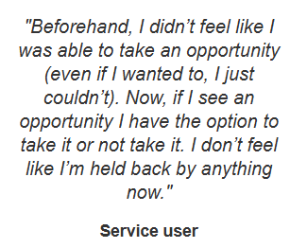

Family Hubs provide a venue and a linked network of local community venues, specialist services and partner organisation so that you can access early help, meet other local families, take part in activities, and join helpful groups.

https://www.wakefieldfamiliestogether.co.uk/family-hubs/

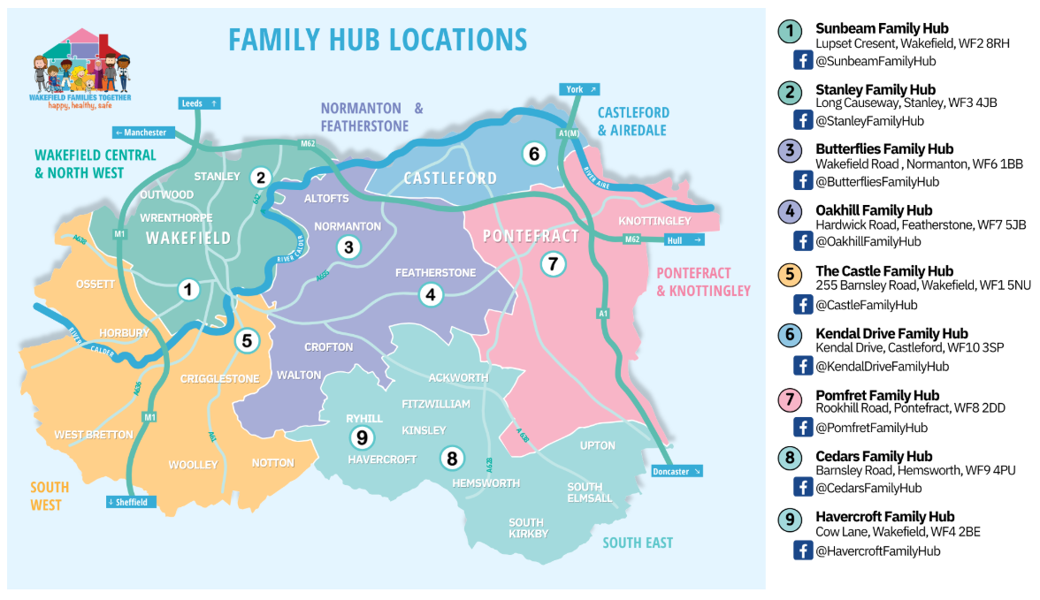

Canine befrienders
Benefits:

- Helps develop communication and social skills.

- The dogs have a calming effect on people’s moods which can create a positive and relaxed atmosphere.

- Can improve motivation to volunteer to work with animals.

- Helps form connections and relationships with others.

- Some people are more comfortable engaging with dogs than they are with people.

What is the Canine Befrienders Service?

Animals can play a key role in supporting people who are experiencing mental health issues.
Spending time with animals can reduce stress and anxiety and can provide a distraction from upsetting symptoms as well as promote social interaction and reduce loneliness.

Following the success of visiting hospital wards by volunteers and their therapy dogs, the
pastoral and spiritual care department have introduced a number of temperament assessed
dogs to its volunteer befriending team, known as our canine befrienders.

The dogs have undergone a full temperament test by an approved dog behaviourist and meet relevant standards in terms of their training and behaviour.

The dogs’ owners/handlers have all passed an assessment in working with their dog, and completed the Trust volunteer recruitment programme.

Arranging a visit

Visits and appointments with canine befrienders can be arranged using a referral form.

For more information about the referral process, or to request a referral form, please contact:

01924 316281 / 6279


pastoral.care@swyt.nhs.uk
Part 7

Volunteering

Volunteers play an important part in the NHS; we would love you to come and join our teams.

Volunteers can offer personal, cultural, spiritual, and creative contributions and offer the time that people need. By working this way, our Trust can provide the best possible, high-quality care to ensure our services are person centred, compassionate, caring, and effective.

By volunteering with us, you can give your community a voice in everything we do, whilst building new friendships, improving your confidence, boosting your CV and improving your own health and wellbeing.

Our volunteer service is accredited by Investing in Volunteers. The Trust is committed to providing good working practice, training, and support to everyone who volunteers.

Contact us on 01924 316426 or volunteer@swyt.nhs.uk or visit the website for an
expression of interest form and further information.

https://www.southwestyorkshire.nhs.uk/get-involved/volunteering/

Thank you

The early intervention team would like to thank everyone involved in co-producing this booklet, including its service users, carers, and staff.

We are grateful for all the offers of information and articles included in the booklet from
local, friendly community services and organisations. We hope you find these beneficial.

Please keep your booklet to hand so that you can keep referring to it if you feel you
need to recap any information.



Permission has been granted from services and organisations to include, circulate and
print their information in this booklet.

All information is correct at the time of publishing (May 2025).

