Tubing Christmas Figures

- Take the tubing from a clean, kitchen/toilet roll.
- Use either sticky back foam or coloured paper, design the outfits and characters.
- Pencil out each part of the design and use pens or coloured foam to create the correct shapes for your chosen character.
- Assemble the largest pieces first and build up!
- Alternatively, you can paint directly onto the tubes, allow the coats to dry in-between adding lighter colours.
- Why not add a name to your characters and use them as a ‘place setting’ for a meal over the festive period?
- To make the scarf for your characters use wool strands. Approximately nine strands depending on how thick the wool. Tie the strands together at one end and ‘plait’ by separating the stands into three sections and placing the left set of strands over the centre set, then placing the right set over the middle and repeat until the plait has reached the end, then tie the end stands.
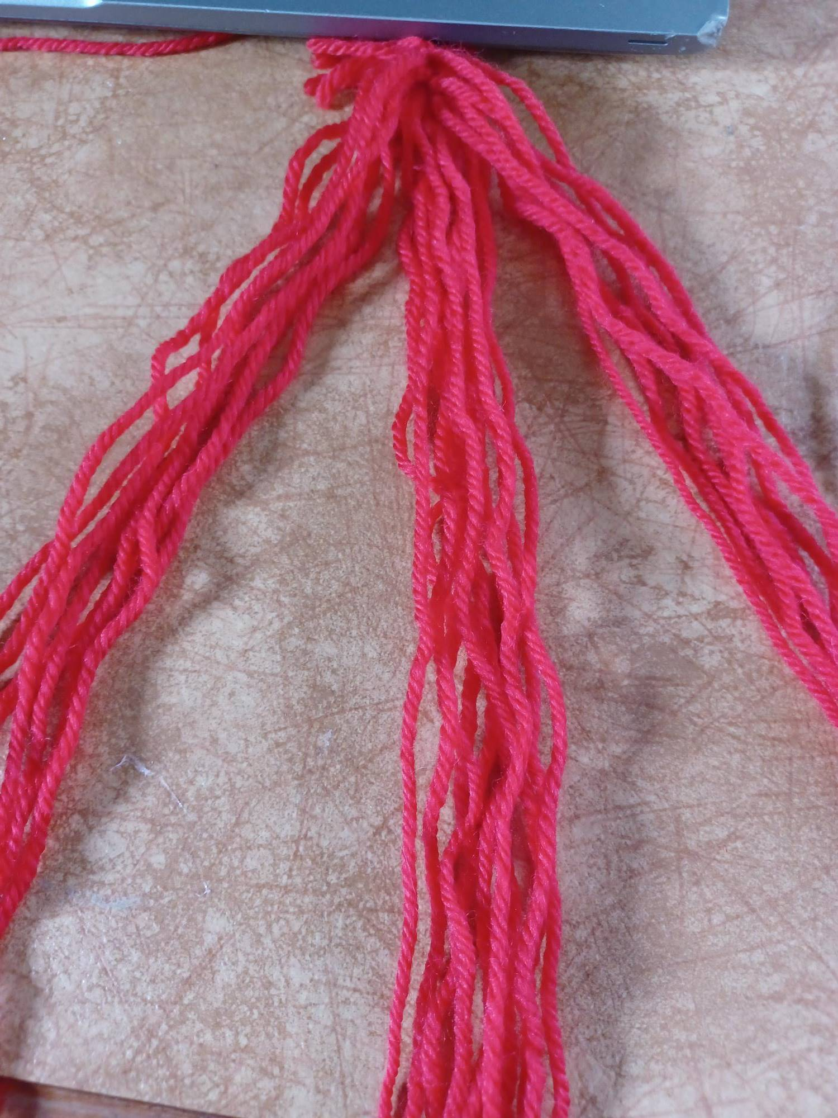
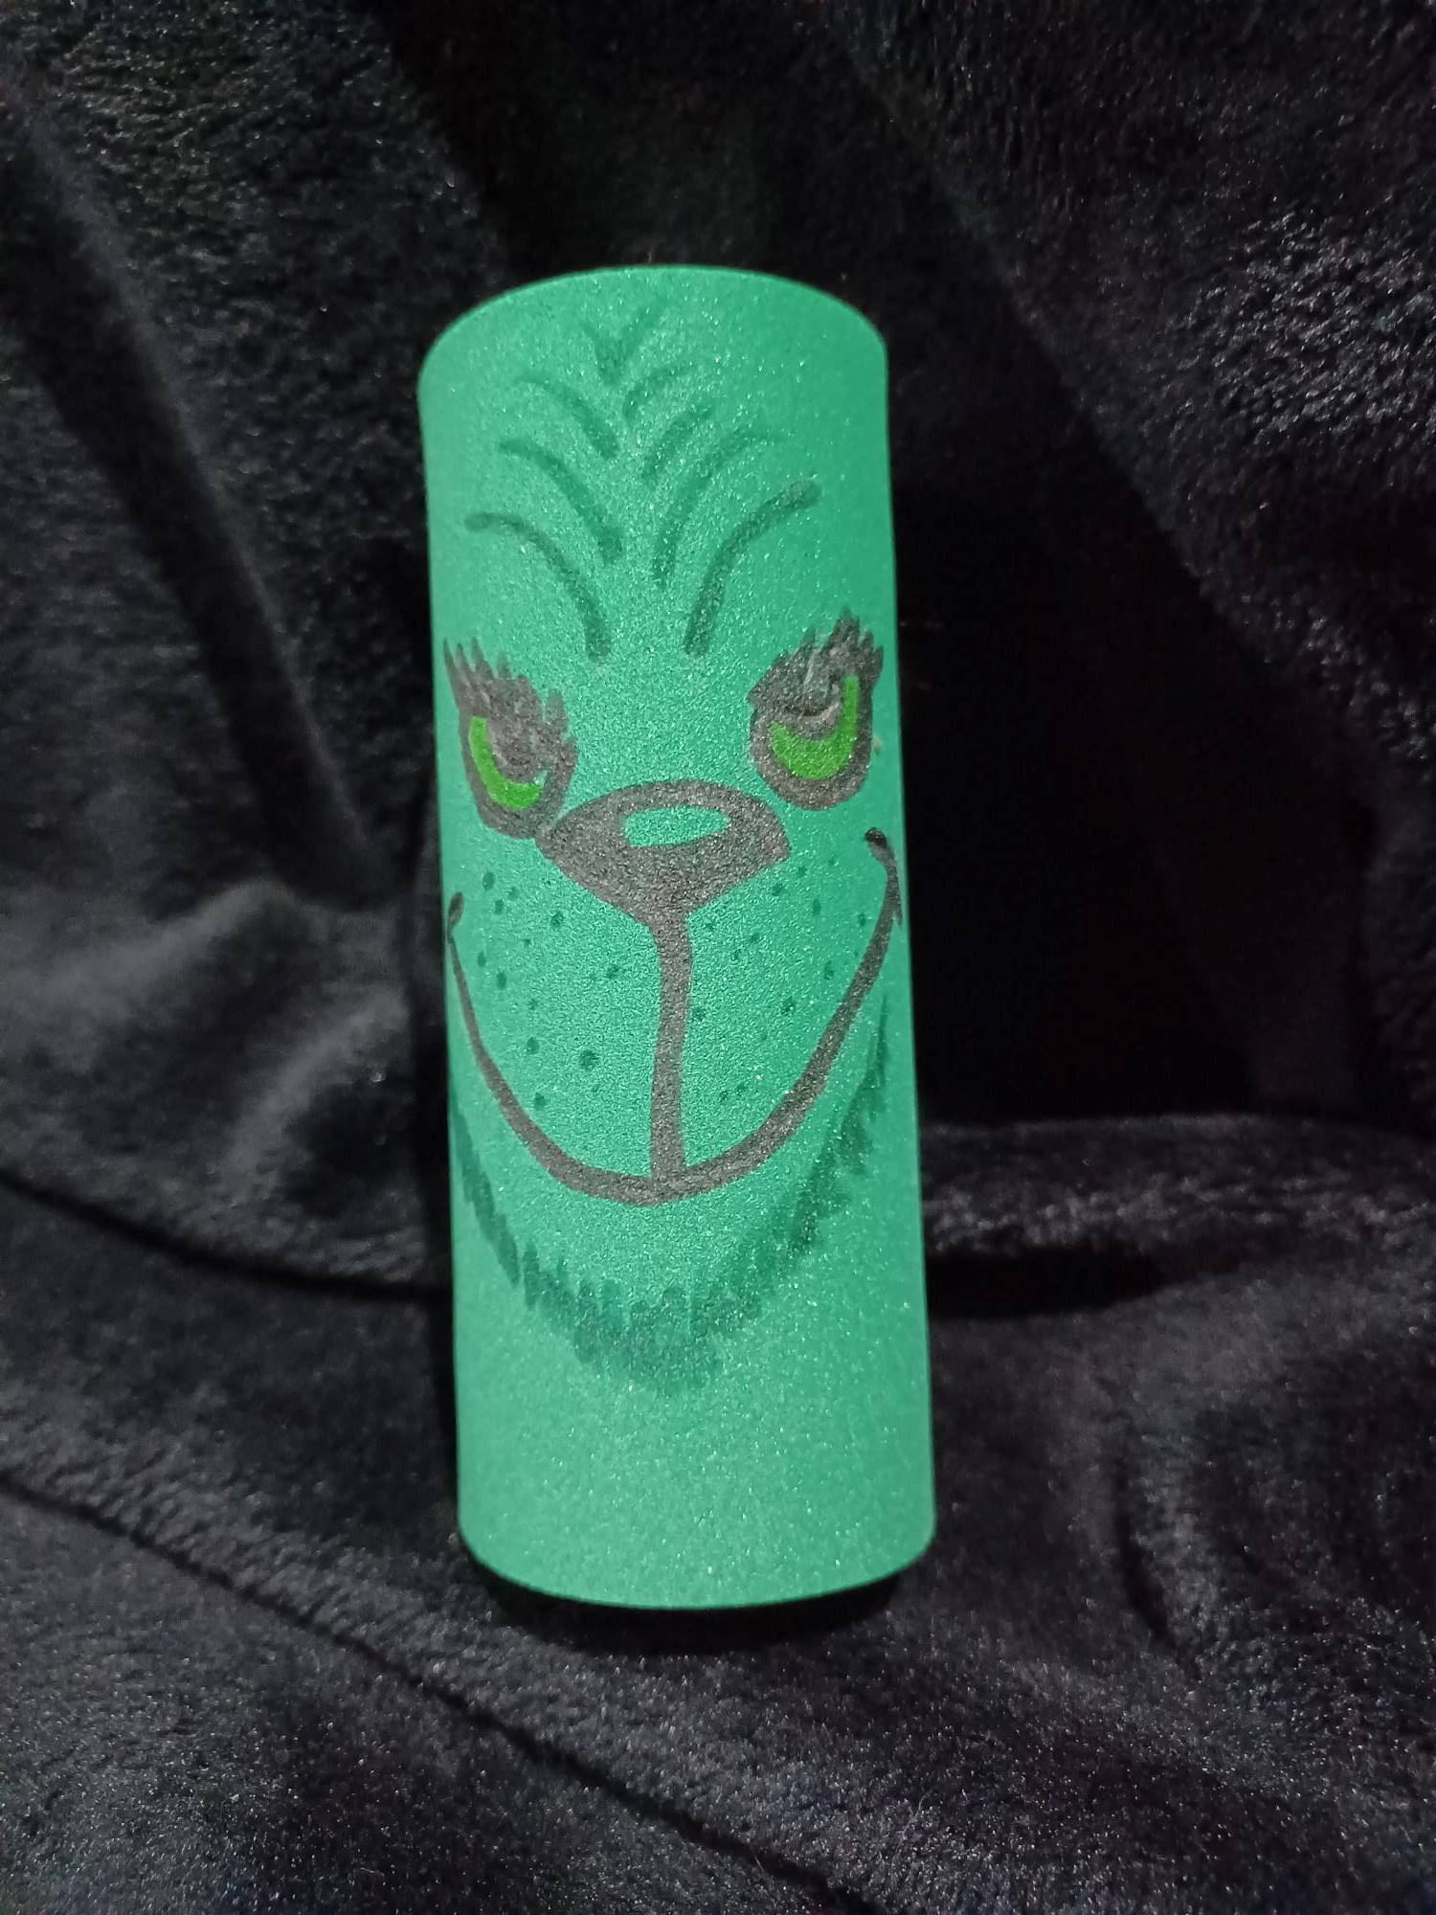
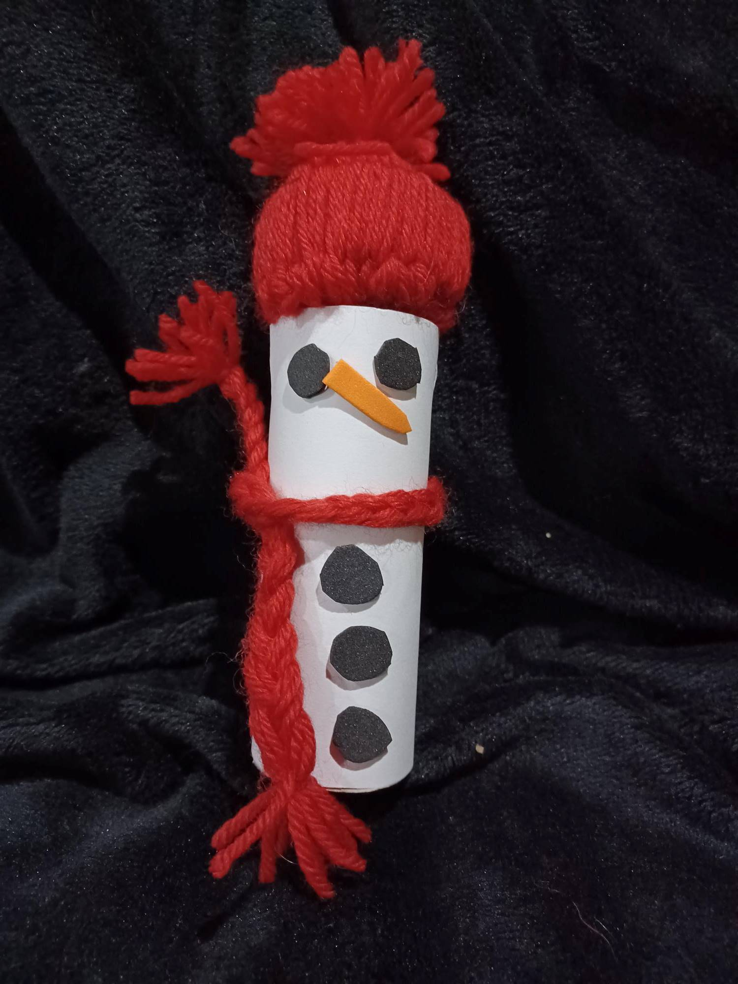
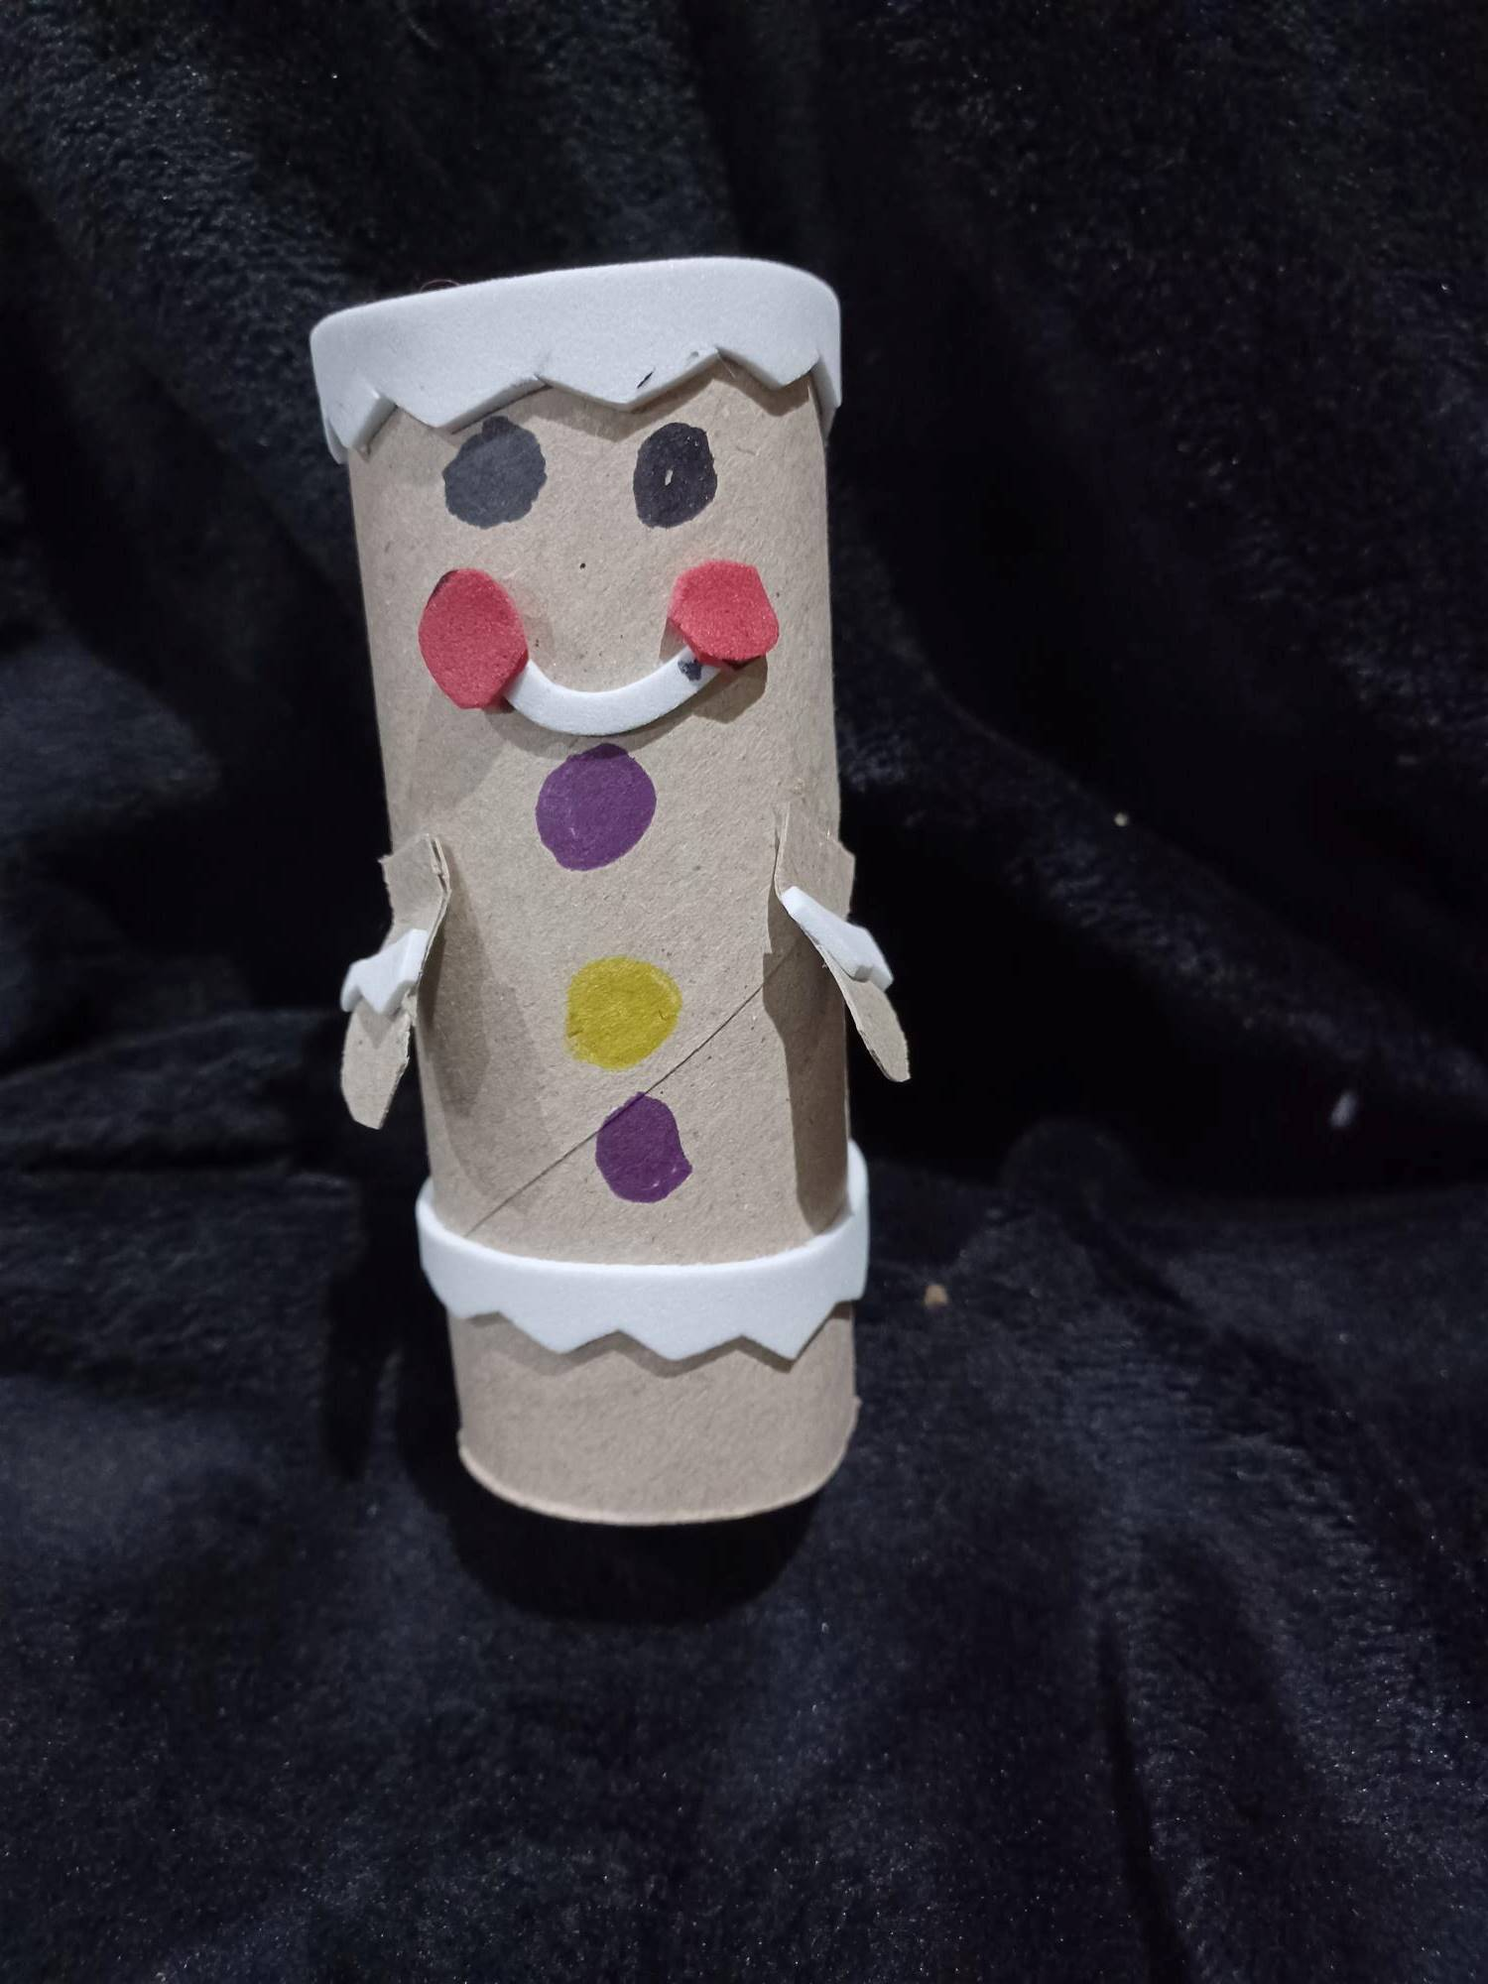
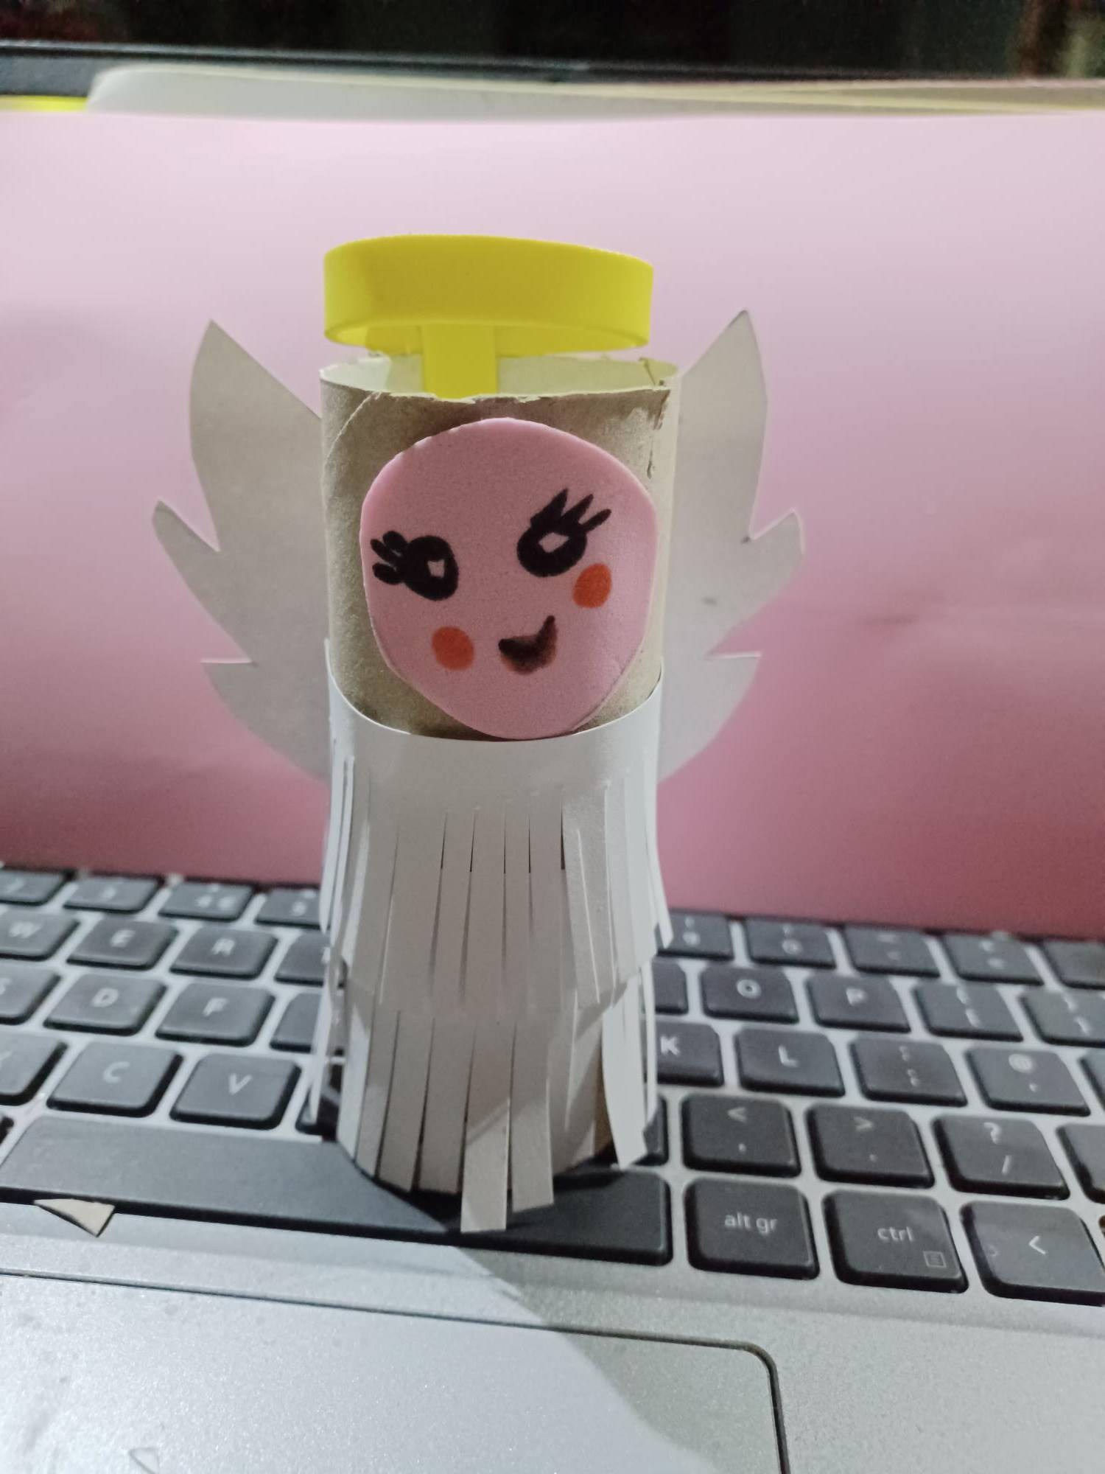
- For the hat see the reverse for the instructions.

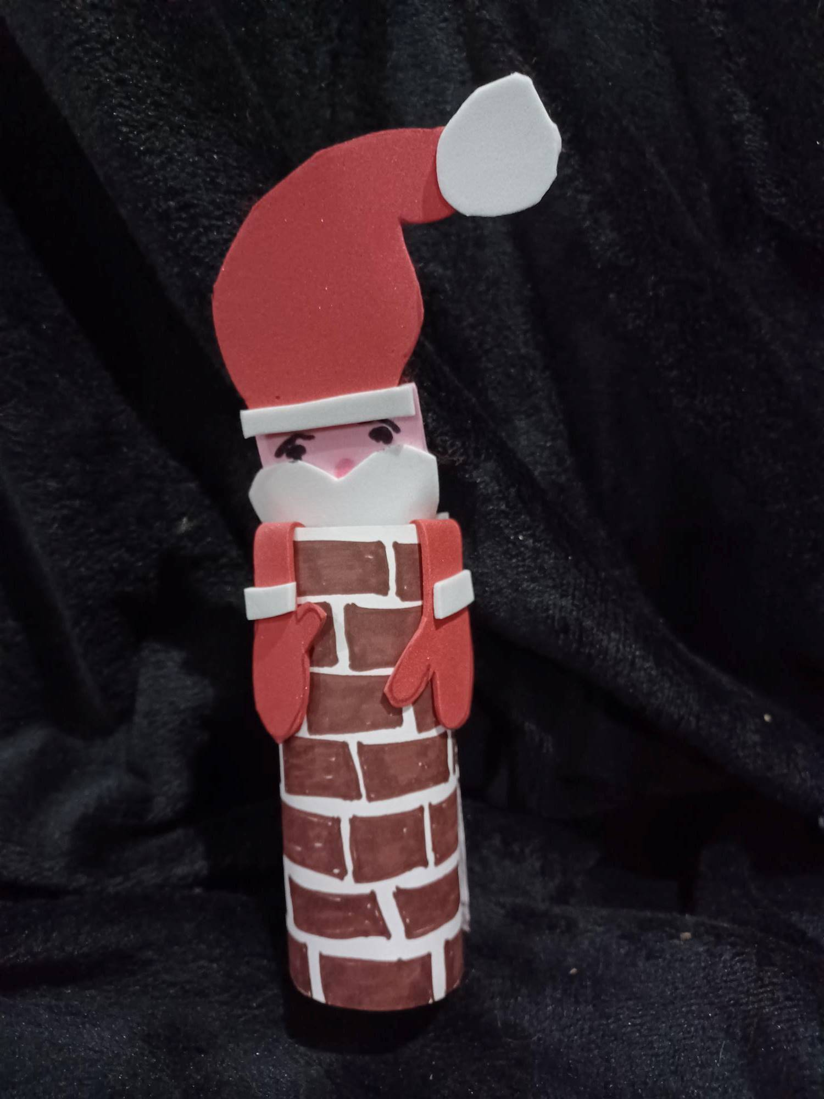
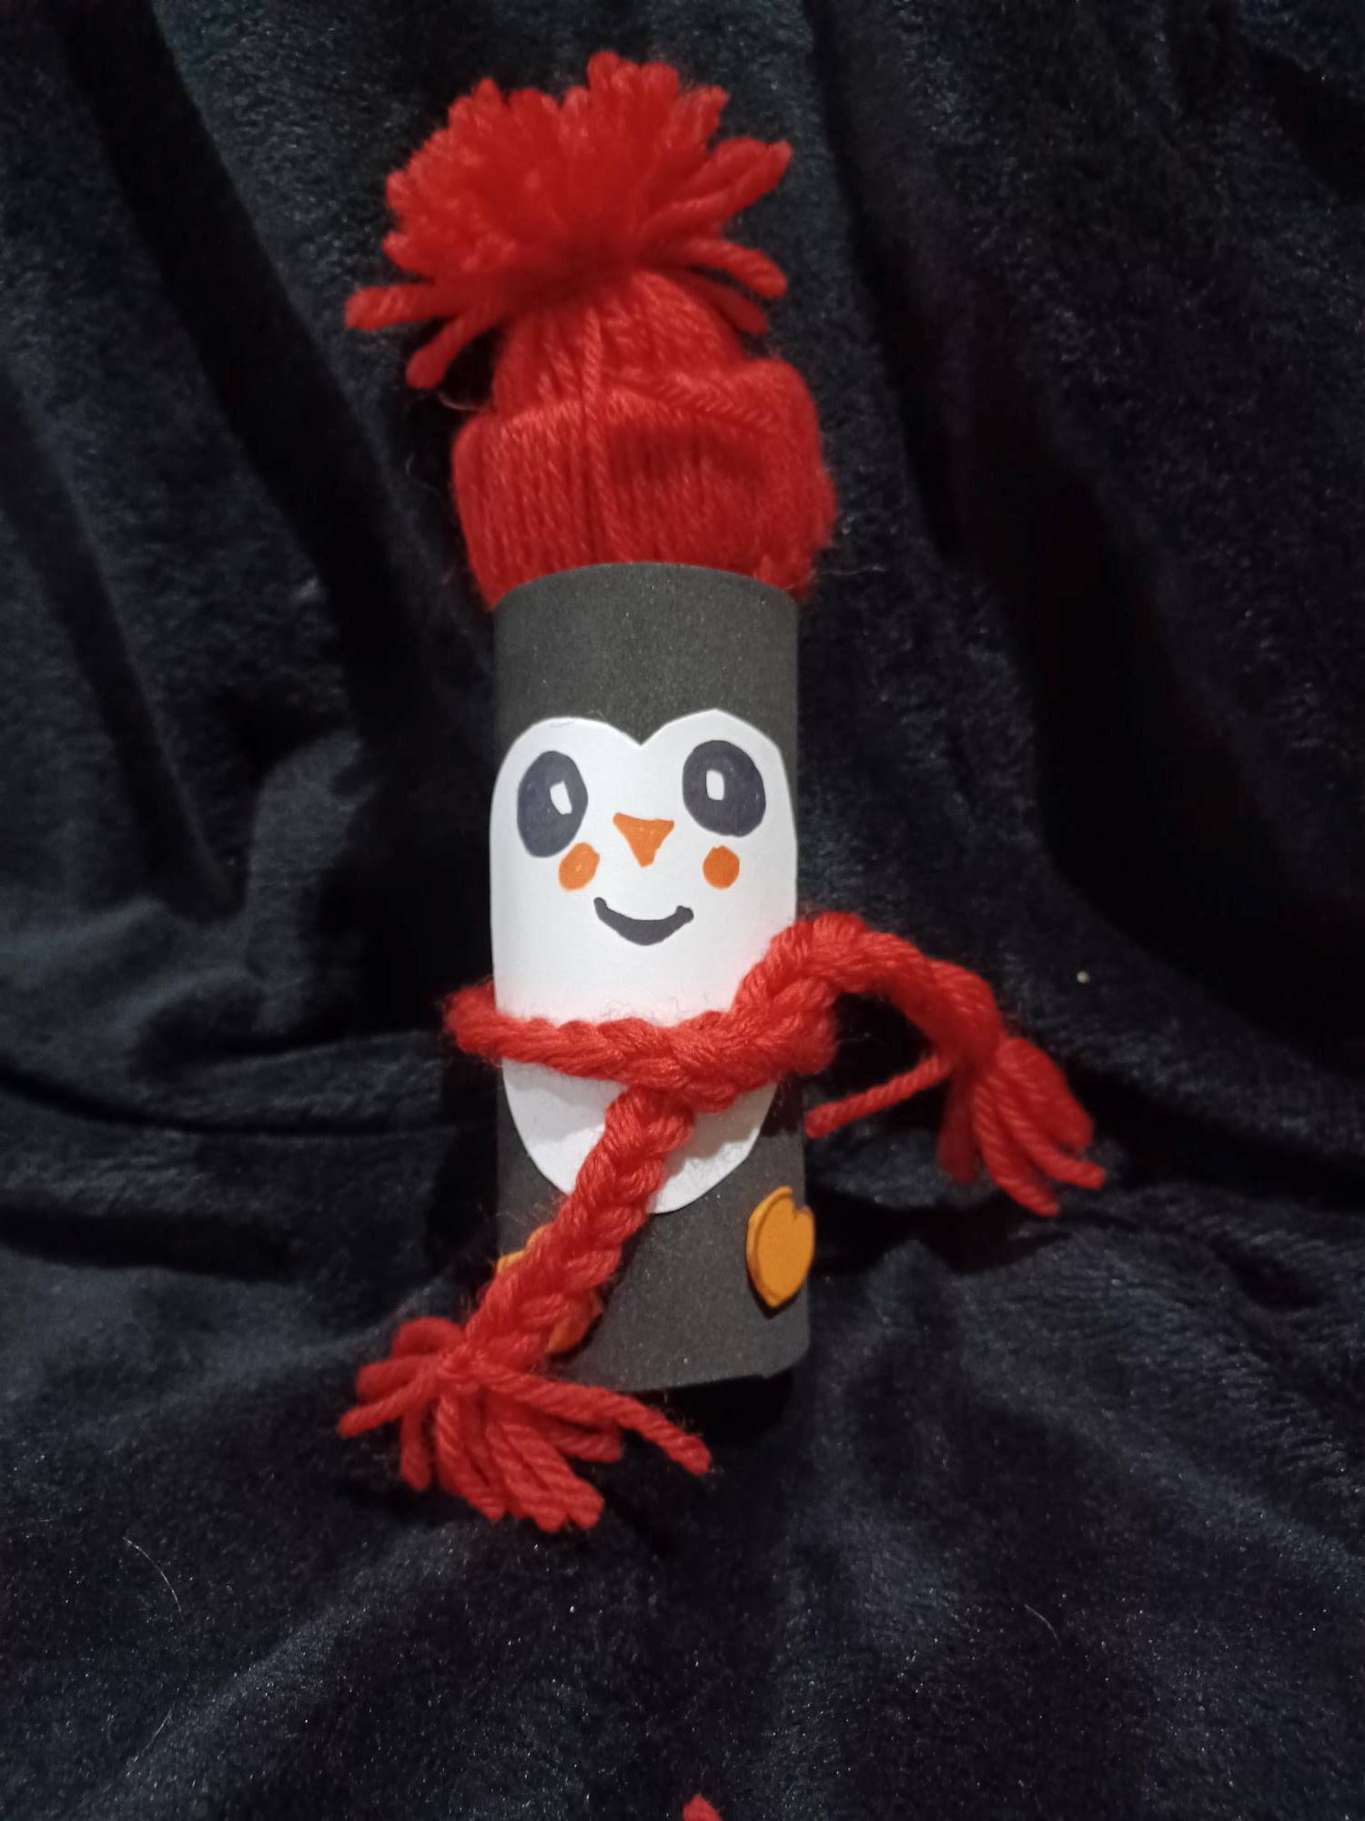
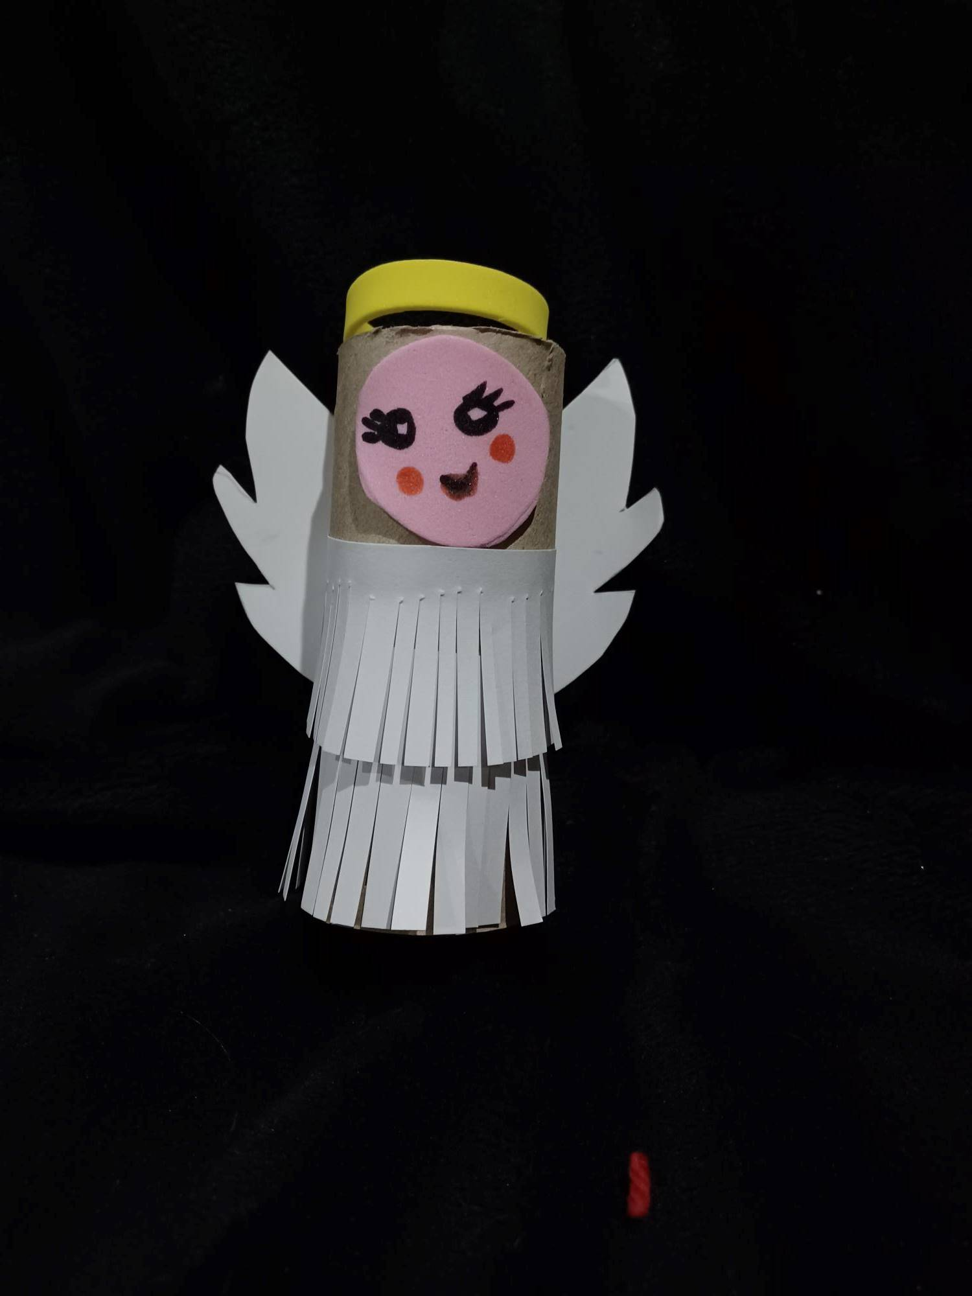
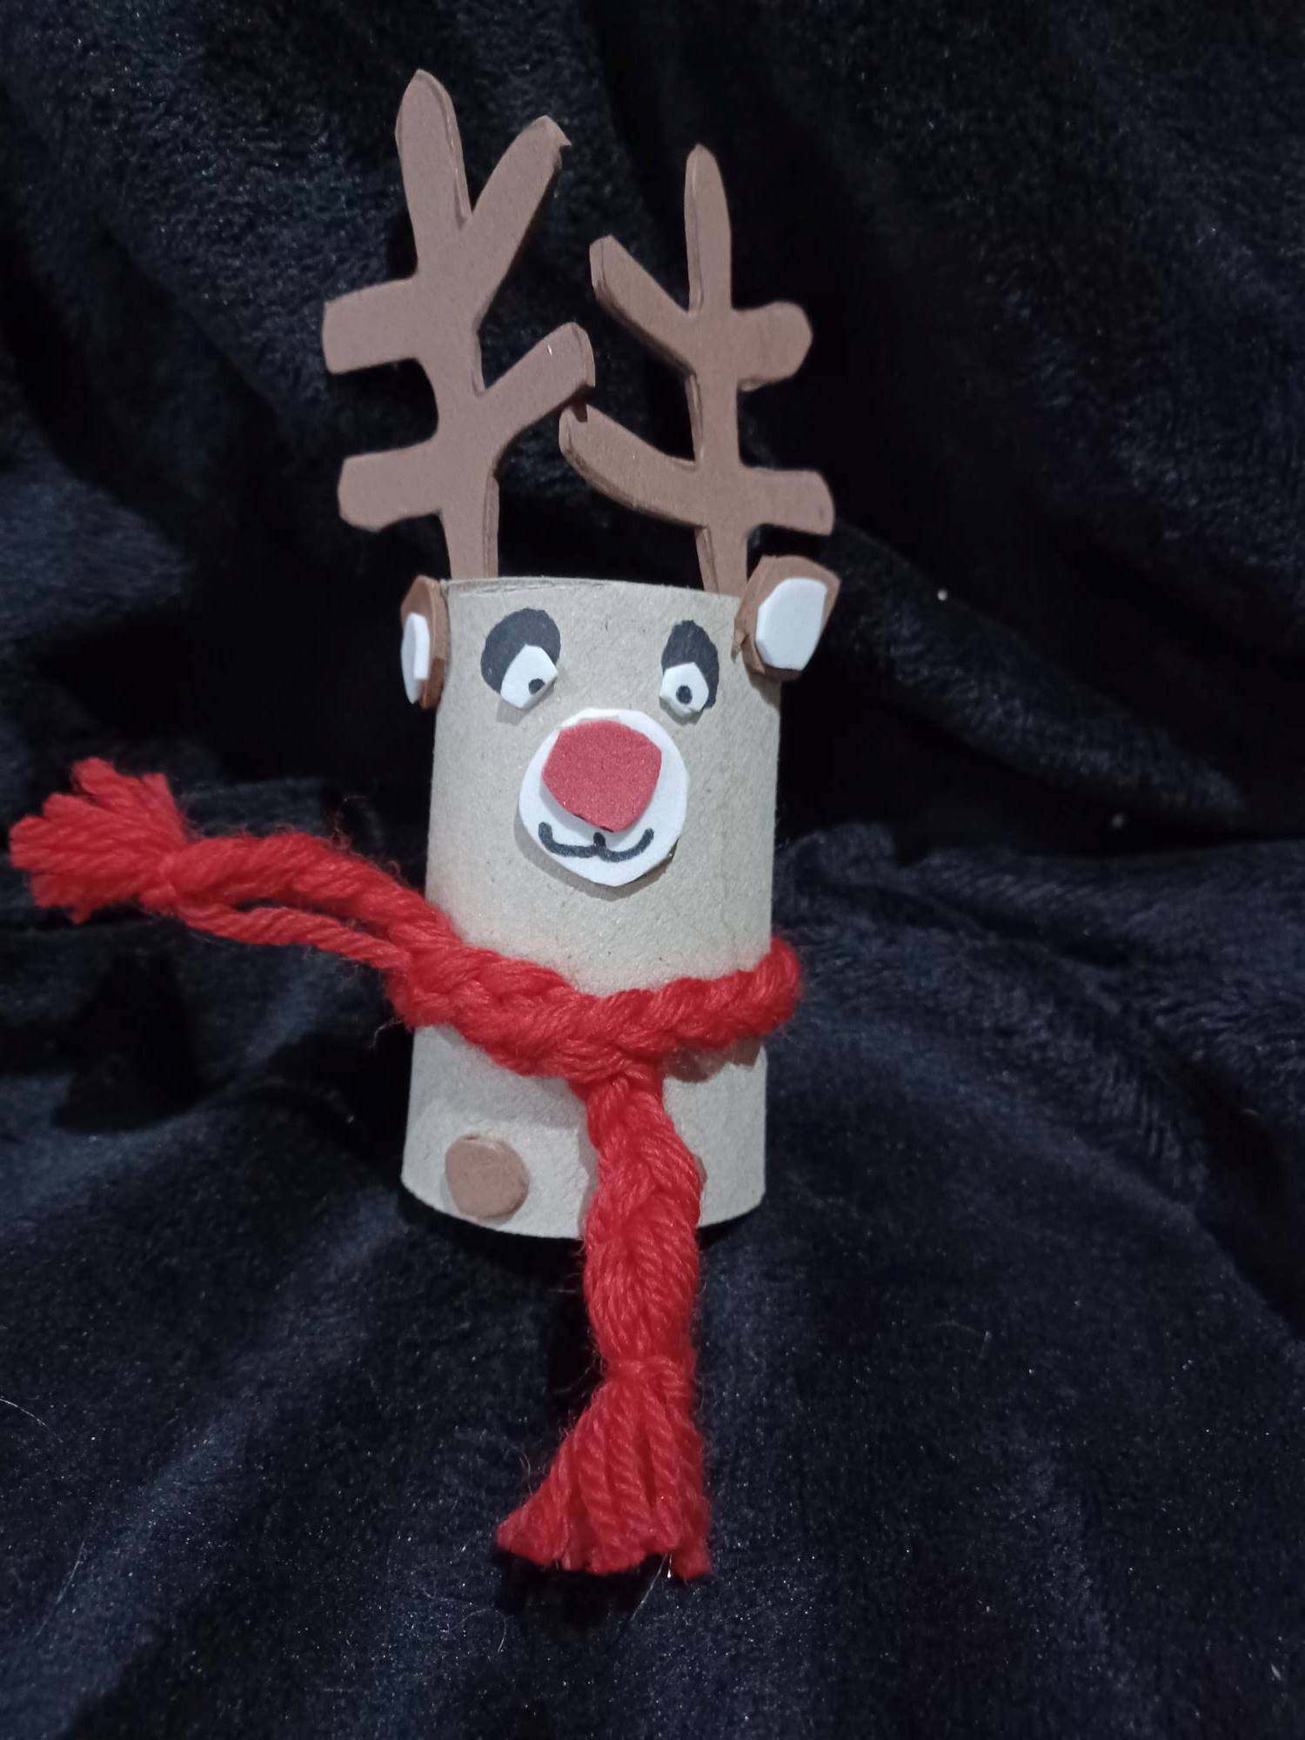
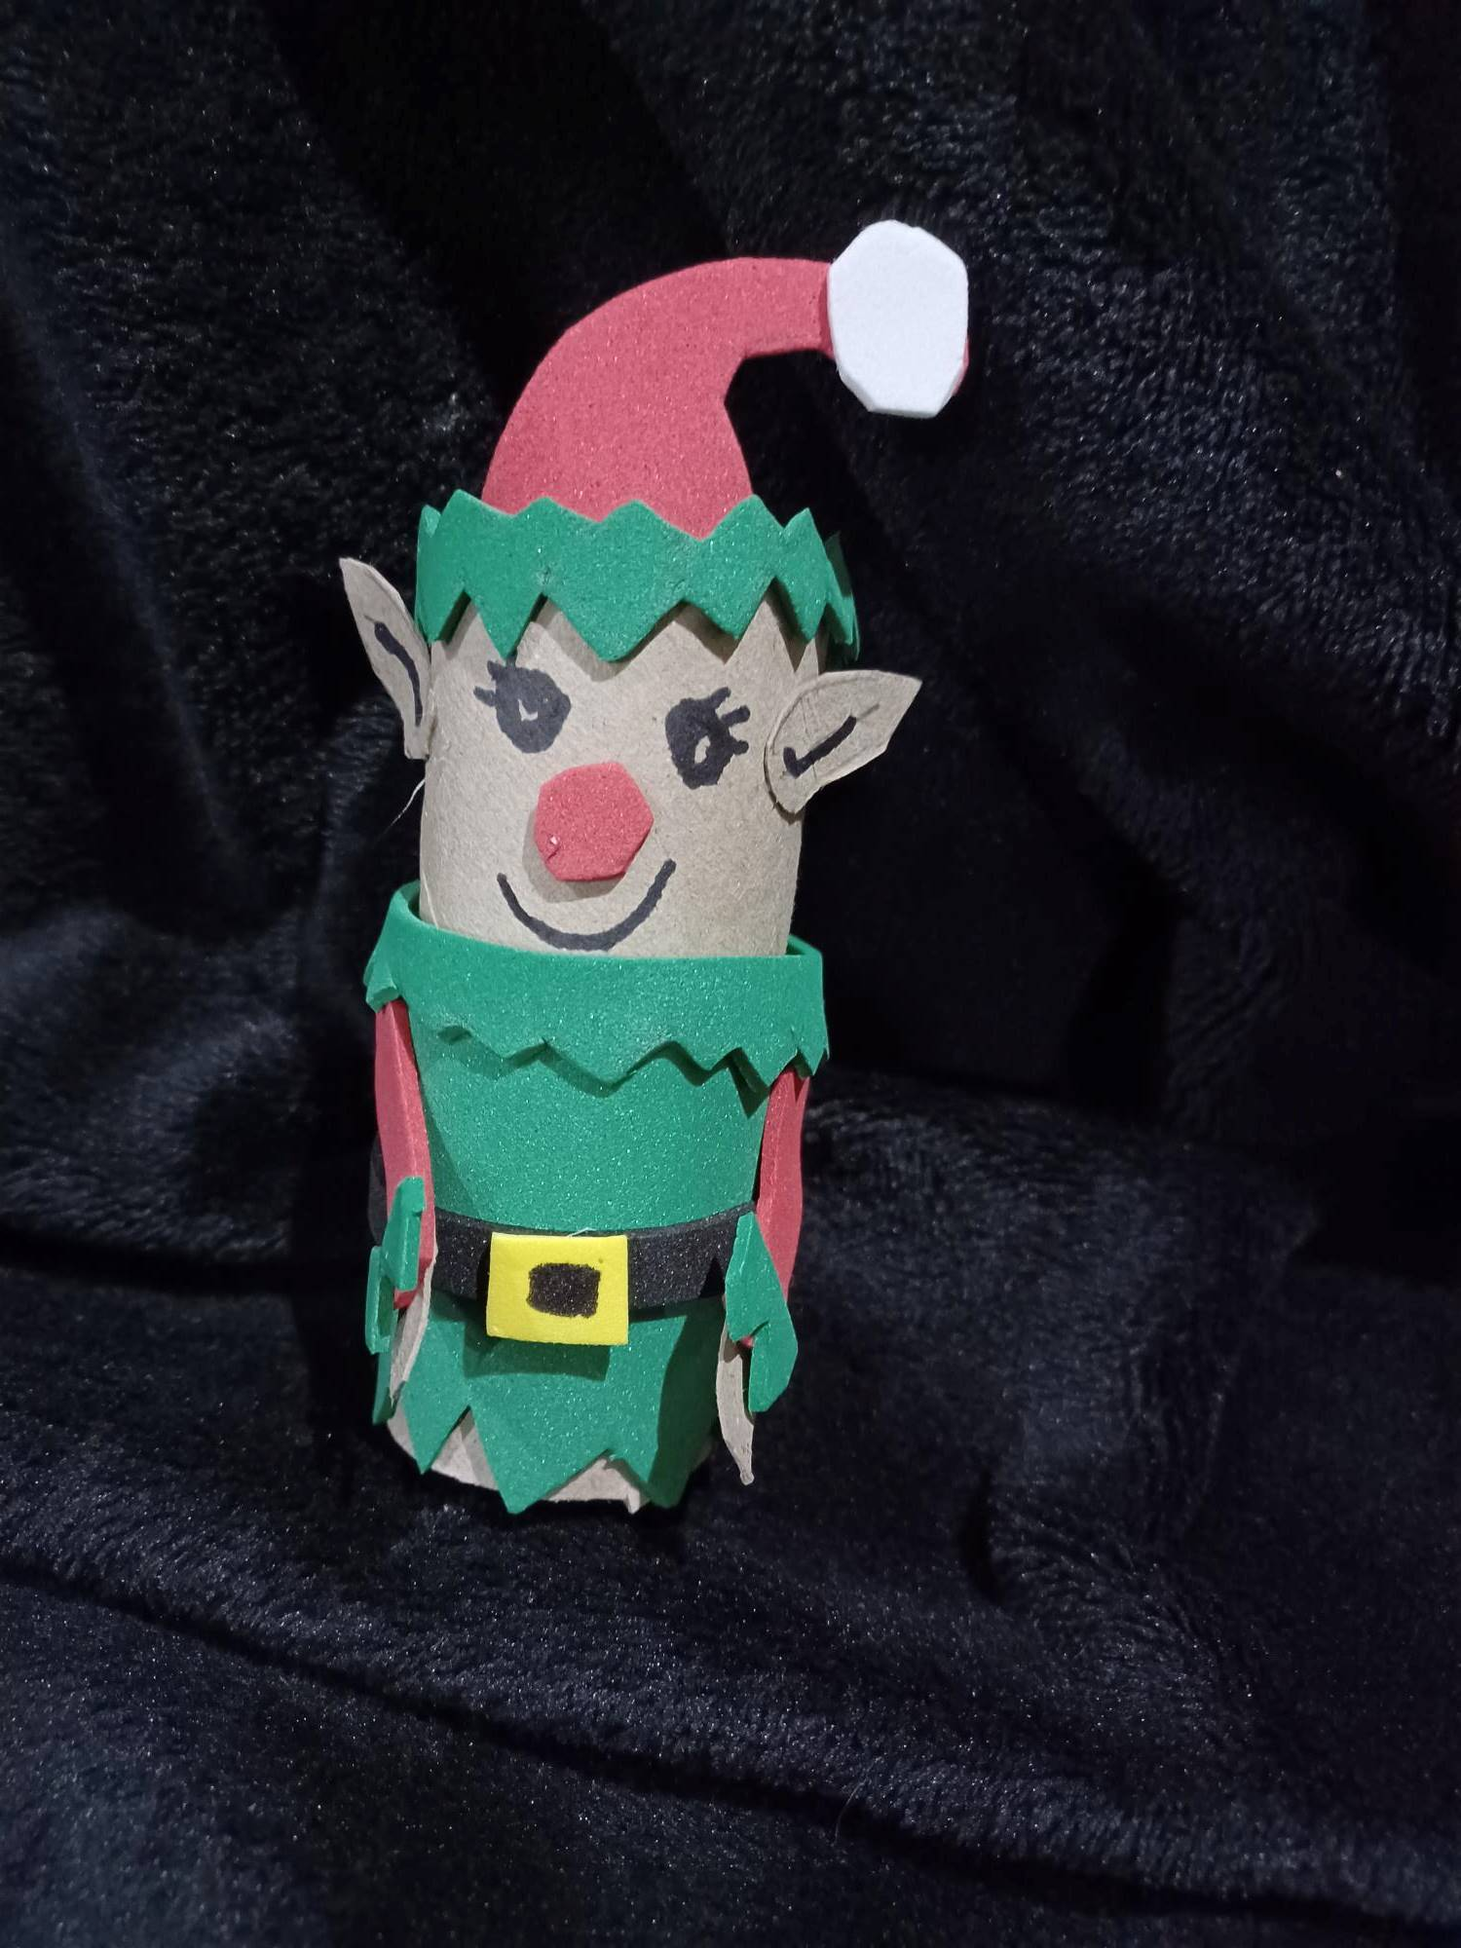

Bobble Hat

- Choose the colour/s wool you want to do the hat and the beard of your gonk.
- Cut a circle of card from your kitchen roll.
- Using a piece of card (approximately 18cm x 10 cm) or a book, wrap the wool you need for your hat around the longest part – about 60 times (more times if you use thin wool, less if you use thick wool) NB: if you don’t do it enough times or you lose count it will not matter as you can cut more lengths later.
- Cut through the centre of the wool so you end up with long strands of wool.
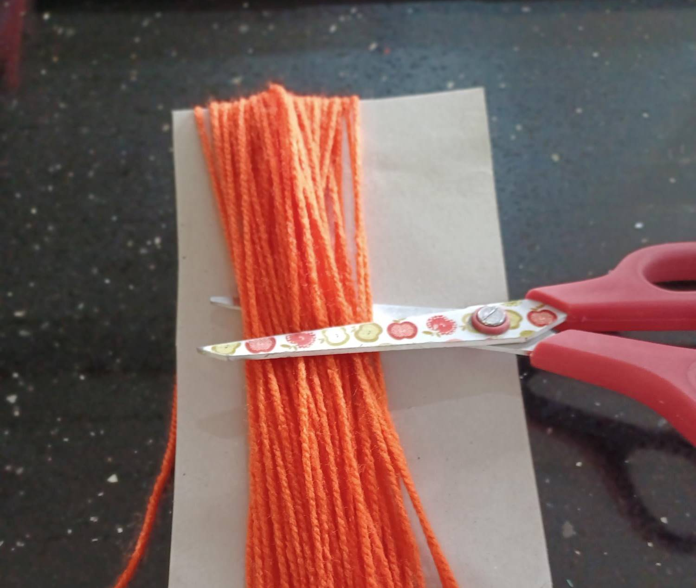
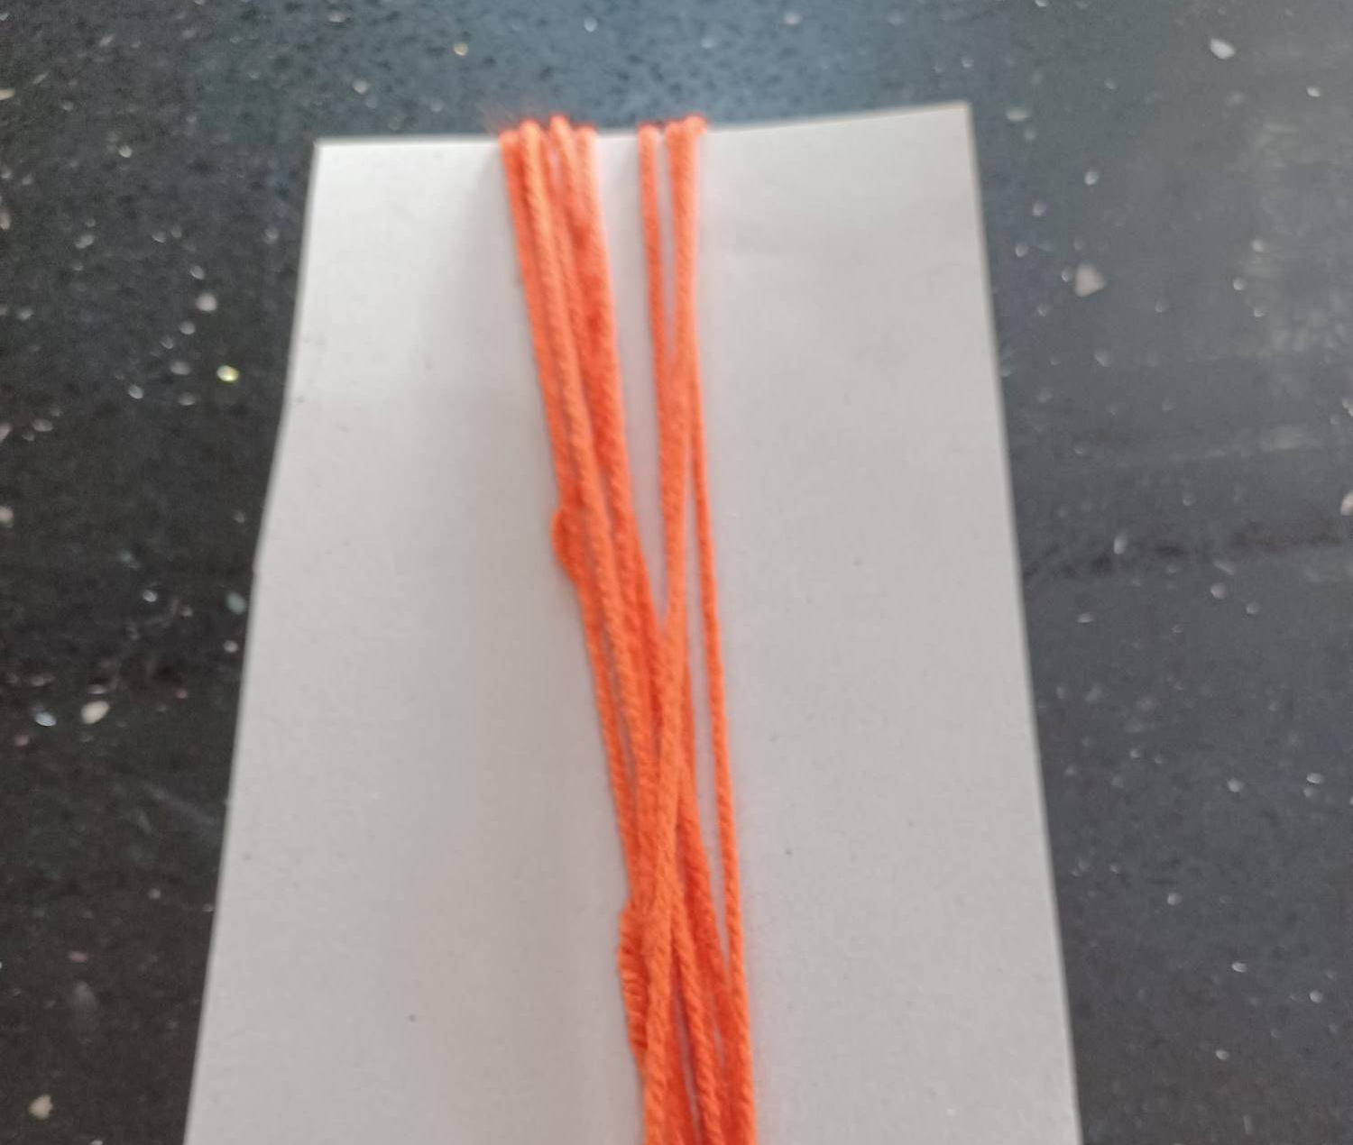
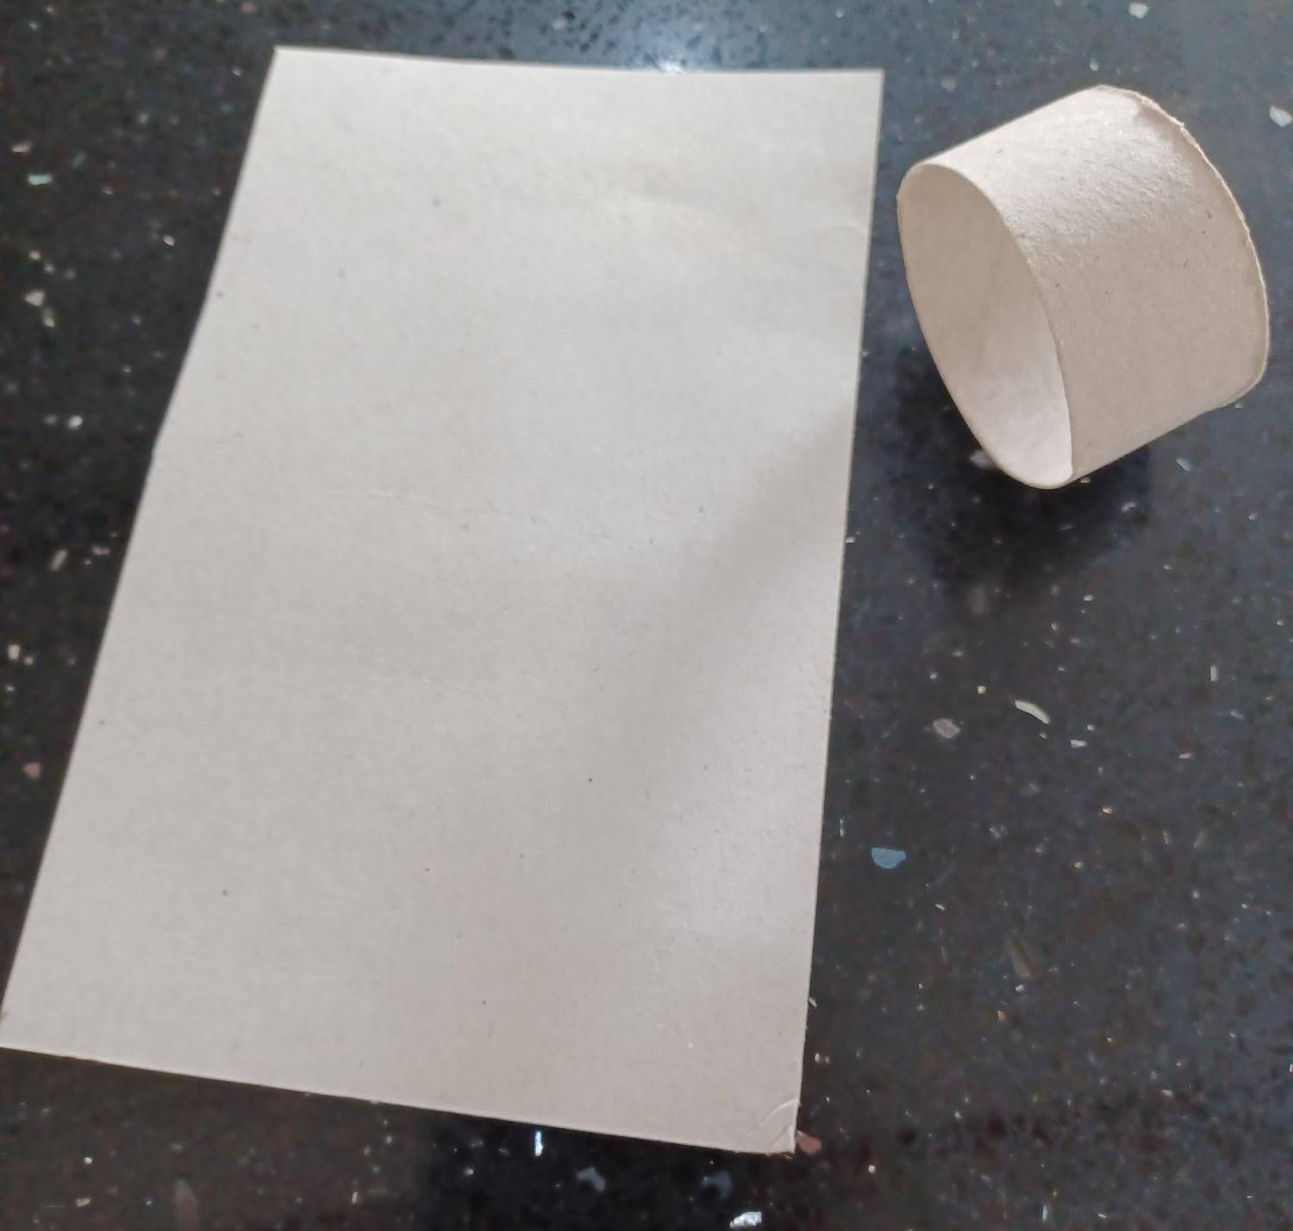
3
4
2

- Take a strand of wool, make a loop and tie to the circle of card as shown.
- Repeat step ‘5’ until the circle of card is full
- Push the long strands of wool back up through the centre of the card.
- Tie a knot to form the hat as shown and trim the strands to chosen size.
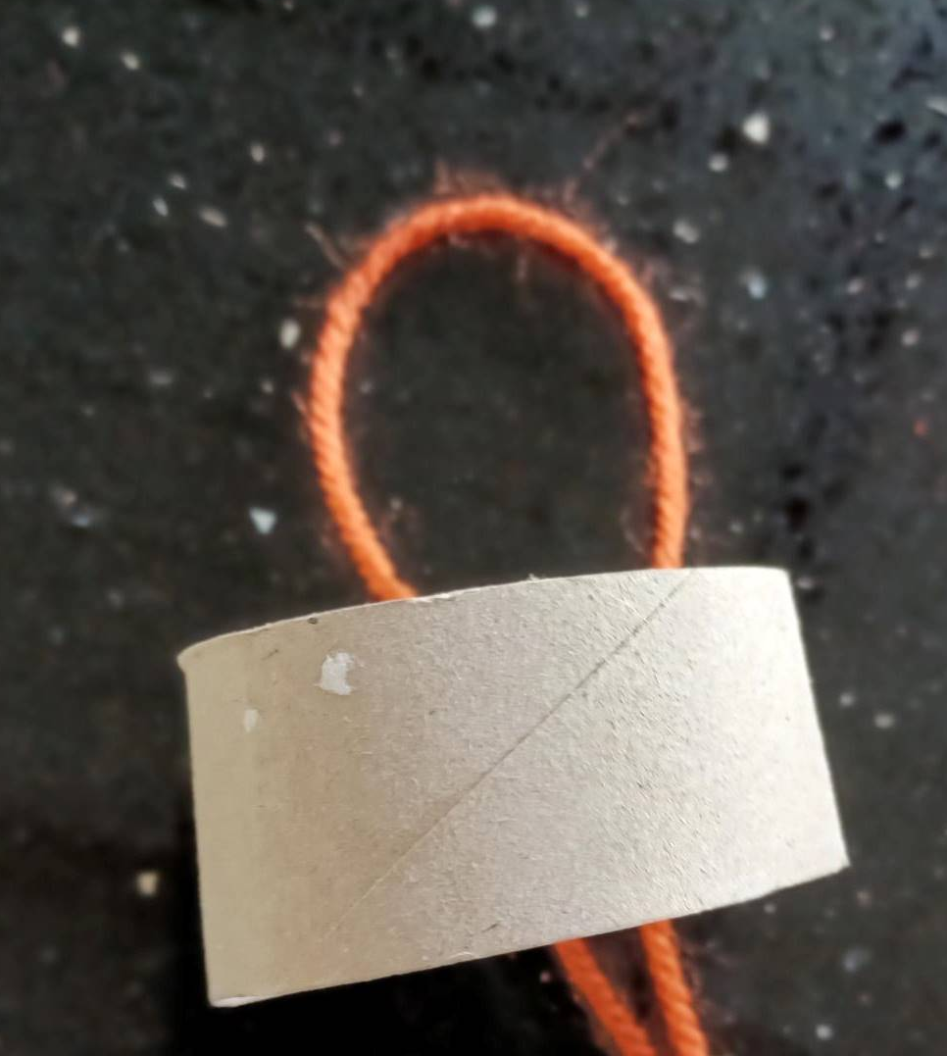
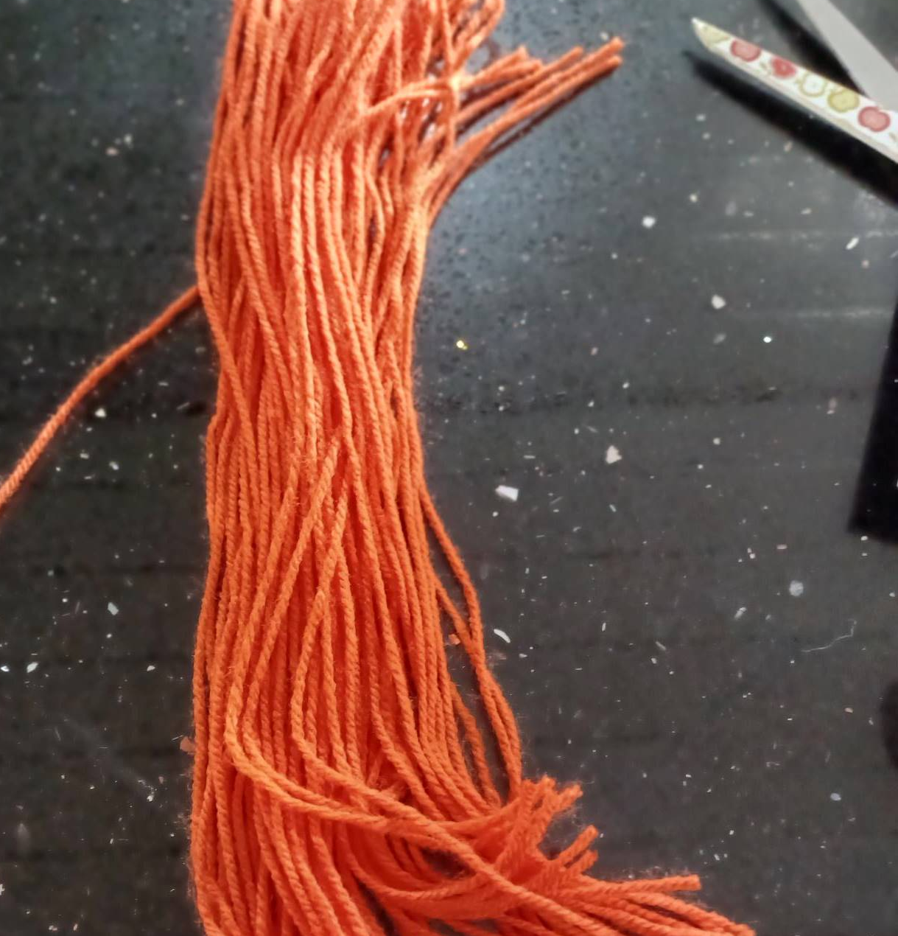
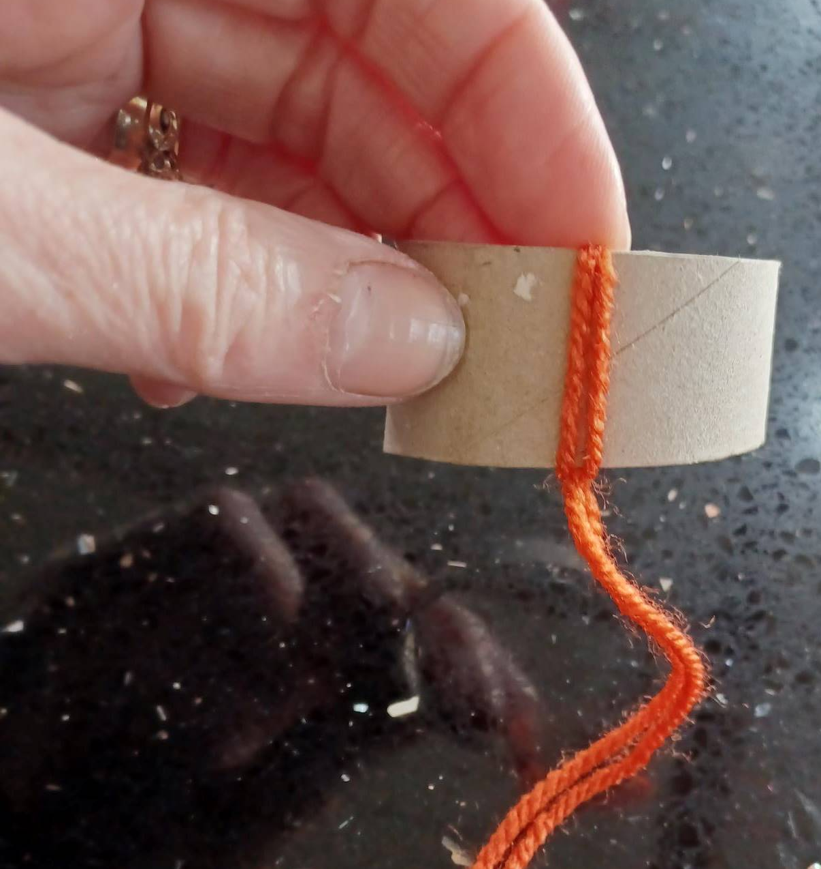
5
5

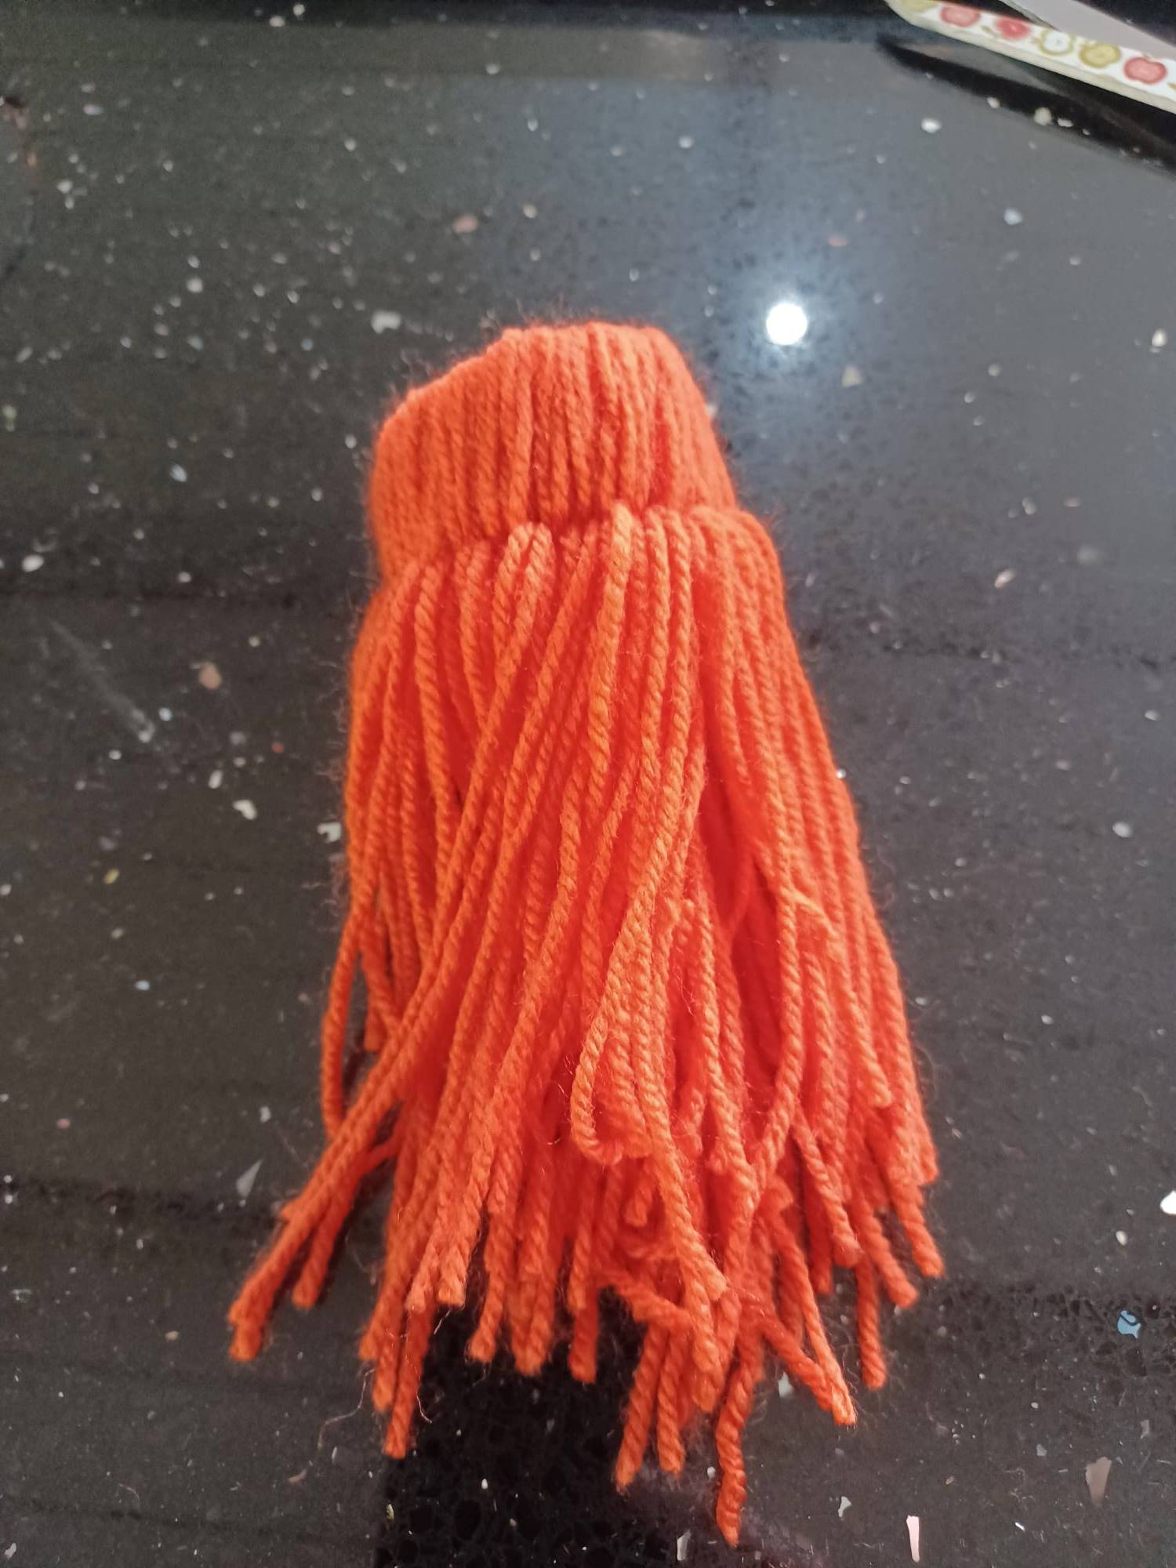
6
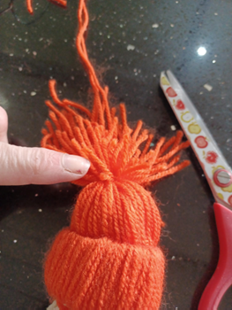
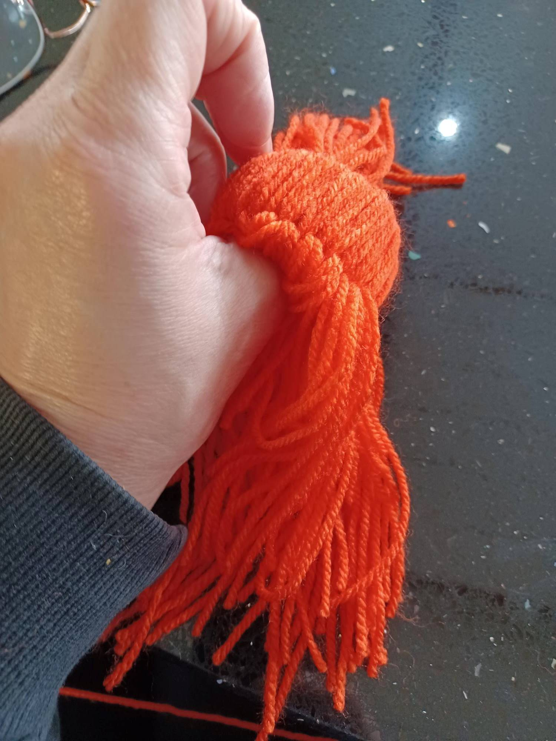
7
8

