Thank you for enrolling onto our online course.

To help you get started please follow these instructions before you join the course.

Download Microsoft Teams to your smartphone, tablet of computer if you have not done so already. You only need to do this once. The apps if free and the data it uses is minimal.

To join a course or meeting click this link at the bottom the email inviting you to the course a few minutes before the course starts.

Once you have clicked the link:
You will go to this screen – click or tap Join now. You will be placed in a waiting area until the facilitator is ready.
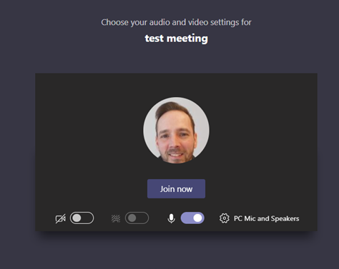

Blur Background

Housekeeping Using Microsoft Teams when in the course/meeting
You will find a set of icon buttons at the bottom centre of your screen when you tap on the screen with your finger or roll the mouse over this section.
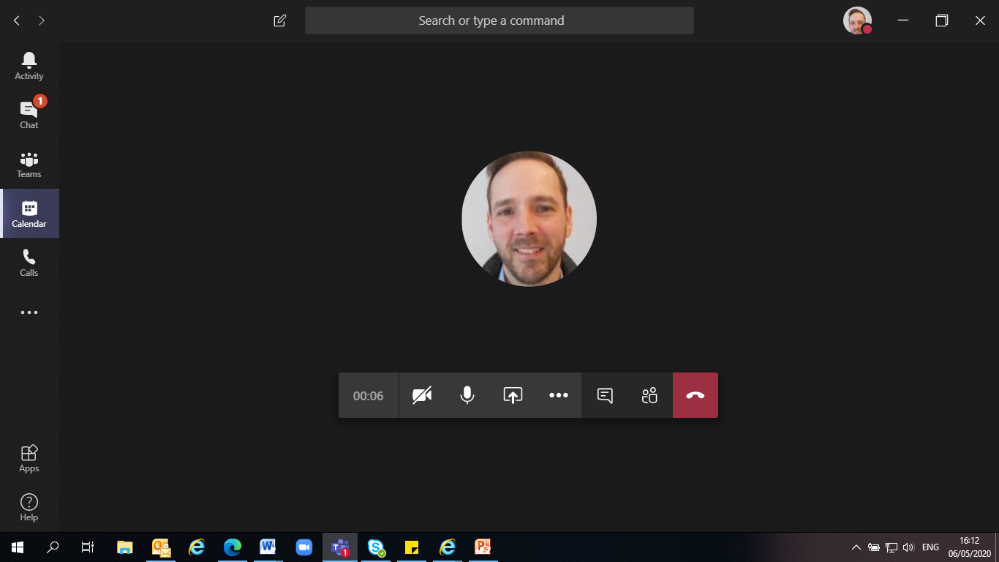
Here you can mute/unmute and turn your camera on and off

Camera on/off Mute/Unmute
Other settings inc. Background

Where possible let people see you as this helps make this more of a safe and friendly environment.
Please mute yourself unless you are speaking or want to speak.
For privacy you can change your background. Click on the 3 dots in the middle of the icons as above. Click on show background effects and select a background. Click Apply and turn on video
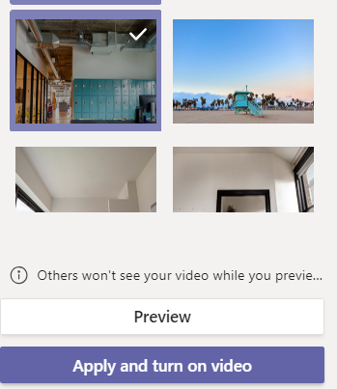
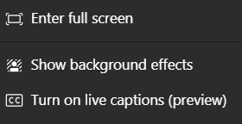
Please read and agree the Group Agreement for online Courses before you join the course

Be kind and courteous
We're all in this together to create a welcoming environment. Let's treat everyone with respect.

Please make no discriminatory remarks about things such as race, religion, culture, sexual orientation, gender or identity

Respect everyone's privacy – please do not use print- screen or repeat what other have said

Don’t Overshare – if you need more help and support please let us know. Talking about past abuse or issues of a sensitive nature can upset and trigger unhelpful emotions in others.

Feel free to suggest a rule that is important to you to the group and facilitator

If you would like help with any of the above please contact us in good time before the course starts.

