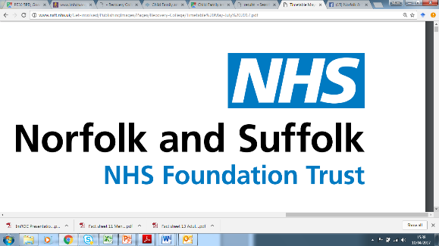**NSFT Recovery College**

**CHIME**

**Workbook Course**



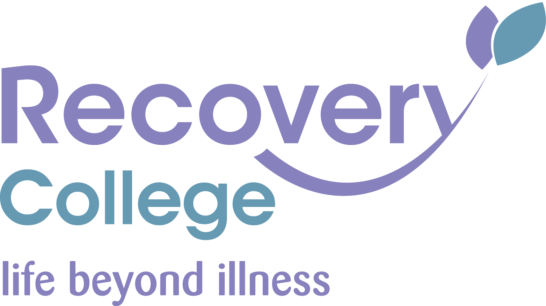**Contents**

Foreword 3

Learning Aims and Learning Outcomes 4

What is Recovery and CHIME? 5

Connectedness 6

Hope and Optimism 7

Identity 8

Meaning in life 10

Empowerment 11

Next steps 12

References and further reading 13

# Foreword

Welcome to our Recovery College training workbook course on ‘**CHIME**’.

It follows on from our ‘Introduction to Recovery’ booklet, but you can complete this as a standalone course.

In this booklet, we will be revising what Recovery means and how this relates to CHIME. There are also various different exercises you can do throughout.

Look out for the symbol for these exercises you can complete on the document. You can also print this document to complete the exercises.

We hope these training booklets are helpful and you enjoy using them.

**NSFT Recovery College**

# Learning Aims and Learning Outcomes

**Learning Aims**

This training book will cover:

* The Recovery College’s definition of **Recovery**.
* Explore what CHIME is and how this relates to Recovery.
* Look at at ‘what’s next’ for you and Recovery.

**Learning Outcomes**

By completing this training, you will be able to:

* **Share** the Recovery College’s definition of Recovery.
* **Explain** that **CHIME** stands for **C**onnectedness, **H**ope, **I**dentity, **M**eaning and **E**mpowerment and are considered key aspects of Recovery.
* **Describe** how the different aspects of CHIME relate to your own Recovery.
* **Create** an identity bubble to represent having a positive sense of self.
* **Decide** on your next step(s) in your Recovery journey.

# What is Recovery and CHIME?

The Recovery College believes in Personal Recovery:

**Recovery is where people find ways of living meaningful and purposeful lives with, or without, ongoing symptoms (Shepherd et al., 2014).**

In the ‘Introduction to Recovery’ training workbook, we discussed three key features as **Hope**, **Choice/Control** and **Opportunity** (Shepherd et al., 2008).

In this training workbook, we are going to look at a more in-depth model that builds on these key 3 features to form five different processes of Recovery known as **CHIME**:

* **C**onnectedness
* **H**ope and Optimism
* **I**dentity
* **M**eaning in life
* **E**mpowerment

(Leamy, et al., 2011)

On the upcoming pages, we are going to consider each of aspect of CHIME individually and complete different activities relating to each one.

# Connectedness

Feeling **connected** to other people in our lives and our environment can be very important in our Recovery.

|  |
| --- |
| **Exercise:** **What can you do to make sure you feel a sense of connections in your life to support your Recovery?** |
| For example, this could be:   * Connecting with family and friends by telephone, text, face-to-face messaging and/social media * Connecting with your environment by spending time in different parts of your home and garden * Going out for a walk once per day (in line with government guidelines) * List your ideas here |

# Hope and Optimism

When we think of **hope**, we mean being **optimistic** but **realistic** about what we can do to support our Recovery.

|  |
| --- |
| **Exercise:**  **List the things you can do to remain hopeful and optimistic to support your Recovery.** |
| For example, this could be:   * Contacting friends and family. * Making a list of your best personal qualities. * Doing hobbies (You can list the hobbies which are important to you below). * Reminding yourself that challenging times do pass. * List your ideas here |
|  |
| **Exercise:**  **List the things you can do to help others to feel hopeful.** |
| For example, this could be:   * Checking in on your neighbours by telephoning them to make sure they are OK. * List your ideas here |

# Identity

Having a strong sense of **identity** and sense of self is important in Recovery. It can be easy for our mental health to take over our identity, but there is so much more to us as individuals and who we are.

We can create identity bubbles to remind us of our identity. For example:

Figure 1: Example Identity Bubble

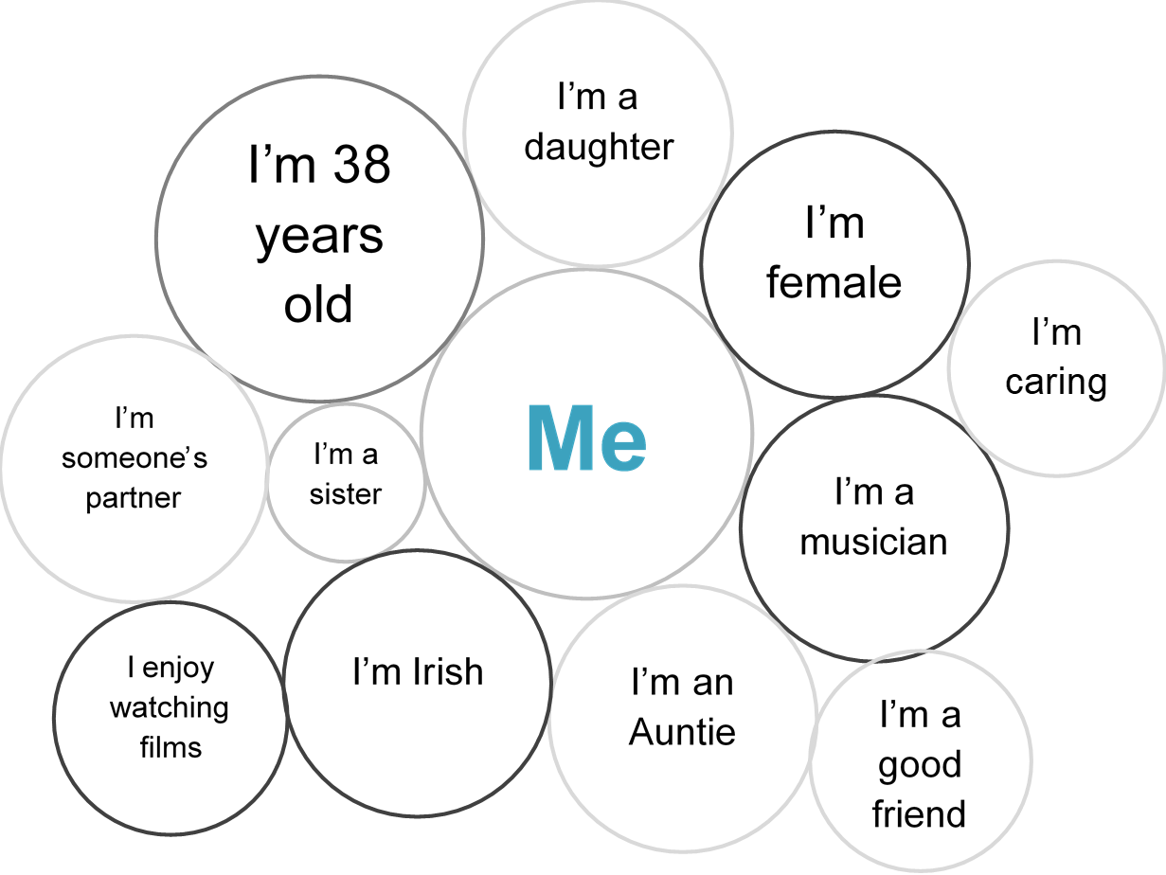

Here this individual has included their **age**, **gender**, **nationality** and her **relationships**, as well as their **interests** and **personal characteristics.**

On the next page, have a go at completing your own identity bubble.

|  |
| --- |
| **Exercise:**  **Complete your identity bubble adding text to each of the bubbles**  Think also about achievements you are proud of or goals you have reached. |



# Meaning in life

Having meaning and purpose in life is very important to Recovery. This gives us a sense of having a good quality of life.

|  |
| --- |
| **Exercise:**  **What is** **important to you and gives your life meaning?**  Below there is a list of different statements.  Tick the boxes next to the statements that are most important to you. (Click the boxes) |

|  |  |
| --- | --- |
| Being honest |  |
| Looking after your general physical health |  |
| Managing your mental health |  |
| The arts (Artwork, music, theatre, film) |  |
| Compassion and caring for others |  |
| Education and training |  |
| Looking after your appearance and self-care |  |
| Friendship |  |
| Personal safety and security |  |
| Religion and spirituality |  |
| Family |  |
| Vocational achievement – *What you do in your everyday life* |  |
| Personal freedom and independence |  |
| Hobbies:  List your hobbies here, such as listening to music |  |
| Courage |  |
| Not giving up and perseverance |  |

|  |
| --- |
| **Exercise:**  **Is there anything else that is important to you and gives your life meaning?**  Also think about if there was anything that used to give your life meaning that you would like to do again. You may have covered this in the previous activity, though. |
| Type/list here. |

If we are aware of what is important to us, we need to make sure that this forms part of our lives. This can give us meaning and purpose.

For example, if family and friends are important to you, make sure you see or contact them often. This could give you meaning and purpose in your Recovery.

# Empowerment

**Empowerment** can be described as having more personal power, becoming more confident, and developing a sense of control over your own life.

|  |
| --- |
| **Exercise:** **How do you think a sense of empowerment could help people  in their Recovery?** |
| For example, this could be:   * They feel they can make their own choices * They can seek opportunities * It improves their own self-esteem. * List your ideas here |

# Next steps

|  |
| --- |
| **Exercise:**  **Now you have learnt about CHIME, what would you like to do next  in your own Recovery journey?**  If you can, type below **one** thing you would like to do next in your Recovery journey.  This can be as simple completing other Recovery College online resources, contacting a family member, or thinking more about what you have learnt by completing this workbook. |
| Type here. |

# References and further reading

Deegan, P.E. (1988). Recovery: The lived experience of rehabilitation. *Psychosocial Rehabilitation Journal*, 9, 4, 11-19.

Leamy, M., Bird, V., Le Boutillier, C., Williams, J., & Slade, M. (2011). Conceptual framework for personal recovery in mental health: systematic review and narrative synthesis. *The British Journal of Psychiatry*, *199*(6), 445-452.

**CHIME Training Book**

Mark Brown Created on 25/03/2020

